A
Major Project Report
on
Prompt-Driven AI Web Automation Using LLM
submitted in partial fulfillment of the requirement for the award of the degree of
BACHELOR OF ENGINEERING
In
COMPUTER SCIENCE & ENGINEERING
By
Abdur Rahman | 160922733043
Mohd Aman | 160922733029
Syed Shafeeq Ahmed | 160922733030
Mohd Ishaq | 160922733041

Under the esteemed guidance of
Name of the Guide
Designation & Dept. of CSE

Department of Computer Science & Engineering
LORDS INSTITUTE OF ENGINEERING AND TECHNOLOGY
(UGC Autonomous)
Approved by AICTE | Affiliated to Osmania University | Estd.2003
Sy.No.32, Himayat Sagar, Near TGPA Junction, Hyderabad-500091, India.
(2026)
 | LORDS INSTITUTE OF ENGINEERING & TECHNOLOGY  (UGC Autonomous)  Approved by AICTE | Affiliated to Osmania University | Estd.2003.  Accredited with ‘A’ grade by NAAC | Accredited by NBA  Department of Computer Science & Engineering

CERTIFICATE
This is to certify that the project report entitled “Prompt-Driven AI Web Automation Using LLM” being Submitted by Abdur Rahman (160922733043), Mohd Aman (160922733029), Syed Shafeeq Ahmed (160922733030), and Mohd Ishaq (160922733041) in partial fulfillment of the requirements for the award of the degree of Bachelor of Engineering in Computer Science and Engineering during the academic year 2024-2025.
This is further certified that the work done under my guidance, and the results of this work have not been submitted elsewhere for the award of any of the degree
Internal Guide | Head of the Department
Name of the Guide  Designation | Dr. TK Shaik Shavali  HOD - CSE

Principal | External Examiner
Dr. Ravi Kishore Singh | Date:

 | LORDS INSTITUTE OF ENGINEERING & TECHNOLOGY  (UGC Autonomous)  Approved by AICTE | Affiliated to Osmania University | Estd.2003.  Accredited with ‘A’ grade by NAAC | Accredited by NBA  Department of Computer Science & Engineering

DECLARATION BY THE CANDIDATE
We, hereby declare that the project report entitled “Prompt-Driven AI Web Automation Using LLM”, under the guidance of Name of the Guide, Designation, Department of Computer Science and Engineering, Lords Institute of Engineering & Technology, affiliated to Osmania University, Hyderabad is submitted in partial fulfillment of the requirements for the award of the degree of Bachelor of Engineering in Computer Science and Engineering.
This is a record of bonafide work carried out by us and the results embodied in this project have not been reproduced or copied from any source. The results embodied in this project report have not been submitted to any other university or institute for the award of any other degree.
Abdur Rahman | 160922733043
Mohd Aman | 160922733029
Syed Shafeeq Ahmed | 160922733030
Mohd Ishaq | 160922733041

 | LORDS INSTITUTE OF ENGINEERING & TECHNOLOGY  (UGC Autonomous)  Approved by AICTE | Affiliated to Osmania University | Estd.2003.  Accredited with ‘A’ grade by NAAC | Accredited by NBA  Department of Computer Science & Engineering

ACKNOWLEDGMENT
First, we wish to thank GOD Almighty who created heavens and earth, who helped us in completing this project and we also thank our Parents who encouraged us in this period.
We would like to thank Name of the Guide, Designation, Dept. of CSE, Lords Institute of Engineering & Technology, affiliated to Osmania University, Hyderabad, our project internal guide, for her guidance and help. Her insight during the course of our major project and regular guidance were invaluable to us.
We would like to express our deep sense of gratitude to Dr. TK Shaik Shavali, Professor & Head of the Department, Computer Science & Engineering, Lords Institute of Engineering & Technology, affiliated to Osmania University, Hyderabad, for his encouragement and cooperation throughout the project.
We would also like to thank Dr. Ravi Kishore Singh, Principal of our college, for extending his help.
Abdur Rahman | 160922733043
Mohd Aman | 160922733029
Syed Shafeeq Ahmed | 160922733030
Mohd Ishaq | 160922733041
(Lords Institute of Engineering and Technology)

 | LORDS INSTITUTE OF ENGINEERING & TECHNOLOGY  (UGC Autonomous)  Approved by AICTE | Affiliated to Osmania University | Estd.2003.  Accredited with ‘A’ grade by NAAC | Accredited by NBA  Department of Computer Science & Engineering

Vision of the Institute:
Lords Institute of Engineering and Technology strives for excellence in professional education through quality, innovation and teamwork and aims to emerge as a premier institute in the state and across the nation.
Mission of the Institute:
- M1: To impart quality professional education that meets the needs of present and emerging technological world.
- M2: To strive for student achievement and success, preparing them for life, career and leadership.
- M3: To provide a scholarly and vibrant learning environment that enables faculty, staff and students to achieve personal and professional growth.
- M4: To contribute to advancement of knowledge, in both fundamental and applied areas of engineering and technology.
- M5: To forge mutually beneficial relationships with government organizations, industries, society and the alumni.

Vision of the Department:
To emerge as a center of excellence for quality Computer Science and Engineering education with innovation, leadership and values.
Mission of the Department:
- DM1: Provide fundamental and practical training through learner – centric Teaching-Learning Process and state-of-the-art infrastructure.
- DM2: Develop design, research, and entrepreneurial skills for successful career.
- DM3: Promote training and activities through Industry-Academia interactions.
Note: DM: Department Mission

 | LORDS INSTITUTE OF ENGINEERING & TECHNOLOGY  (UGC Autonomous)  Approved by AICTE | Affiliated to Osmania University | Estd.2003.  Accredited with ‘A’ grade by NAAC | Accredited by NBA  Department of Computer Science & Engineering

B.E. Computer Science and Engineering Program Outcomes (POs):
Engineering Graduates will be able to:
S. No. | Program Outcomes (POs)
1. | PO1: Engineering Knowledge: Apply knowledge of mathematics, natural science, computing, engineering fundamentals and an engineering specialization as specified in WK1 to WK4 respectively to develop to the solution of complex engineering problems.
2. | PO2: Problem Analysis: Identify, formulate, review research literature and analyze complex engineering problems reaching substantiated conclusions with consideration for sustainable development. (WK1 to WK4)
3. | PO3: Design/Development of Solutions: Design creative solutions for complex engineering problems and design/develop systems/components/processes to meet identified needs with consideration for the public health and safety, whole-life cost, net zero carbon, culture, society and environment as required. (WK5)
4. | PO4: Conduct Investigations of Complex Problems: Conduct investigations of complex engineering problems using research-based knowledge including design of experiments, modelling, analysis & interpretation of data to provide valid conclusions. (WK8).
5. | PO5: Engineering Tool Usage: Create, select and apply appropriate techniques, resources and modern engineering & IT tools, including prediction and modelling recognizing their limitations to solve complex engineering problems. (WK2 and WK6)
6. | PO6: The Engineer and The World: Analyze and evaluate societal and environmental aspects while solving complex engineering problems for its impact on sustainability with reference to economy, health, safety, legal framework, culture and environment. (WK1, WK5, and WK7).
7. | PO7: Ethics: Apply ethical principles and commit to professional ethics, human values, diversity and inclusion; adhere to national & international laws. (WK9)
8. | PO8: Individual and Collaborative Team work: Function effectively as an individual, and as a member or leader in diverse/multi-disciplinary teams.
9. | PO9: Communication: Communicate effectively and inclusively within the engineering community and society at large, such as being able to comprehend and write effective reports and design documentation, make effective presentations considering cultural, language, and learning differences
10. | PO10: Project Management and Finance: Apply knowledge and understanding of engineering management principles and economic decision-making and apply these to one’s own work, as a member and leader in a team, and to manage projects and in multidisciplinary environments.
11. | PO11: Life-Long Learning: Recognize the need for, and have the preparation and ability for i) independent and life-long learning ii) adaptability to new and emerging technologies and iii) critical thinking in the broadest context of technological change. (WK8)
12. | PO12: Entrepreneurship: Identify opportunities, assess risks and apply innovative thinking to create value and wealth for the betterment of the individual and society at large.

 | LORDS INSTITUTE OF ENGINEERING & TECHNOLOGY  (UGC Autonomous)  Approved by AICTE | Affiliated to Osmania University | Estd.2003.  Accredited with ‘A’ grade by NAAC | Accredited by NBA  Department of Computer Science & Engineering

B.E. Computer Science and Engineering Program Specific Outcomes (PSO’s):
PSO1 | Professional Skills: Implement computer programs in the areas related to algorithms, system software, multimedia, web design, big data analytics and networking for efficient analysis and design of computer-based systems of varying complexity
PSO2 | Problem-Solving Skills: Apply standard practices and strategies in software service management using open-ended programming environment with agility to deliver a quality service for business success
PSO3 | Successful Career and Entrepreneurship: Pursue higher studies and research, and adapt to the latest tools and technologies for developing products for the betterment of society

 | LORDS INSTITUTE OF ENGINEERING & TECHNOLOGY  (UGC Autonomous)  Approved by AICTE | Affiliated to Osmania University | Estd.2003.  Accredited with ‘A’ grade by NAAC | Accredited by NBA  Department of Computer Science & Engineering

Course Outcomes: C424 - Major Project
Student will be able to
CO. No | Description | Blooms  Taxonomy  Level
C424.1 | Apply Flask-SocketIO and Playwright for real-time browser automation | L6
C424.2 | Implement Claude AI tool_use for autonomous web agent decision-making | L6
C424.3 | Design PDF parsing and structured data extraction for AI form filling | L5
C424.4 | Develop Flask-Login authentication and session management | L3
C424.5 | Deploy responsive Bootstrap 5 UI with live SocketIO streaming | L5

 | LORDS INSTITUTE OF ENGINEERING & TECHNOLOGY  (UGC Autonomous)  Approved by AICTE | Affiliated to Osmania University | Estd.2003.  Accredited with ‘A’ grade by NAAC | Accredited by NBA  Department of Computer Science & Engineering

Course Articulation Matrix:
Mapping of Course Outcomes (CO) with Program Outcomes (PO) and Program Specific Outcomes (PSO’s):
Course  Outcome s  (CO) | PO1 | PO2 | PO3 | PO4 | PO5 | PO6 | PO7 | PO 8 | PO9 | PO10 | PO11 | PSO1 | PSO2
C424.1. | 3 | 3 | 3 | 2 | 3 | 2 | 1 | 2 | 2 | 2 | 3 | 3 | 3
C424.2. | 3 | 3 | 3 | 3 | 3 | 2 | 1 | 2 | 2 | 2 | 3 | 3 | 3
C424.3. | 3 | 3 | 3 | 2 | 3 | 2 | 1 | 1 | 2 | 2 | 3 | 3 | 3
C424.4. | 3 | 2 | 3 | 1 | 2 | 1 | 2 | 2 | 2 | 2 | 3 | 3 | 3
C424.5. | 3 | 2 | 3 | 1 | 3 | 2 | 1 | 2 | 2 | 2 | 3 | 3 | 3
Average | 3.0 | 2.6 | 3.0 | 1.8 | 2.8 | 1.8 | 1.2 | 1.8 | 2.0 | 2.0 | 3.0 | 3.0 | 3.0

Level:
1- Low correlation (Low), 2- Medium correlation (Medium), 3-High correlation (High)
SDG Mapping:
SDG | Mapped  Indicator | SDG | Mapped  Indicator | SDG | Mapped  Indicator
1 NO  POVERTY |  | 7 AFFORDABLE AND  CLEAN ENERGY |  | 13 CLIMATE  ACTION
2 ZERO  HUNGER |  | 8 DECENT WORK AND  ECONOMIC GROWTH |  | 14 LIFE  BELOW WATER
3 GOOD HEALTH  AND WELL-BEING |  | 9 INDUSTRY, INNOVATION  AND INFRASTRUCTURE | ✓ | 15 LIFE  ON LAND
4 QUALITY  EDUCATION | ✓ | 10 REDUCED  INEQUALITIES | ✓ | 16 PEACE, JUSTICE  AND STRONG INSTITUTIONS
5 GENDER  EQUALITY |  | 11 SUSTAINABLE CITIES  AND COMMUNITIES |  | 17 PARTNERSHIPS  FOR THE GOALS
6 CLEAN WATER  AND SANITATION |  | 12 RESPONSIBLE  CONSUMPTION AND PRODUCTION

ABSTRACT
This project presents a Prompt-Driven AI Web Automation system that leverages Large Language Models (LLMs) to autonomously interact with web pages through natural language instructions. The platform integrates Flask-SocketIO for real-time communication, Playwright for headless browser automation, and Anthropic's Claude AI with tool_use capabilities for intelligent decision-making. The system comprises two core modules: a Web Data Extraction Agent that scrapes structured data from any website based on user prompts, and an AI Form Filler Bot that parses uploaded PDF/DOCX resumes and autonomously fills web forms using extracted personal information.
The Web Data Extraction Agent accepts a URL and a natural language query, navigates the target page using Playwright, extracts the page content, and employs Claude AI to intelligently parse and structure the requested data into clean tabular formats. The AI Form Filler Bot utilises pymupdf4llm and python-docx for document parsing, Claude AI for field mapping, and Playwright for automated form interaction including text input, dropdown selection, checkbox toggling, and form submission.
The application features Flask-Login authentication with SQLite-backed user management, real-time progress streaming via SocketIO, task history tracking, and export capabilities to Excel and CSV using pandas and openpyxl. The responsive Bootstrap 5 dark-themed UI provides live status updates during automation tasks, making the entire process transparent and interactive. The system runs on port 5050 and demonstrates how LLM-powered agents can bridge the gap between natural language understanding and practical web automation.
Keywords: Web Automation, Large Language Model, Claude AI, Playwright, Flask-SocketIO, Natural Language Processing, Browser Automation, Form Filling, Data Extraction, PDF Parsing.

TABLE OF CONTENTS
Title Page | i
Certificate | ii
Declaration | iii
Acknowledgment | iv
Vision & Mission of Institute / Department | v
Program Outcomes (POs) | vi
Program Specific Outcomes (PSOs) | vii
Course Outcomes | viii
Course Articulation Matrix & SDG Mapping | ix
Abstract | x
Table of Contents | xi
List of Figures | xii
List of Tables | xiii
CHAPTER 1: INTRODUCTION | 1
1.1 Introduction | 1
1.2 Scope of the Project | 2
1.3 Objectives | 3
1.4 Problem Formulation | 3
1.5 Existing System | 4
1.6 Proposed System | 5
CHAPTER 2: LITERATURE SURVEY | 7
2.1 – 2.15 Literature Reviews | 7
CHAPTER 3: SYSTEM ANALYSIS AND DESIGN | 12
3.1 Feasibility Study | 12
3.2 Software Requirement Specification | 13
3.3 System Requirements | 15
3.4 System Architecture | 16
3.5 UML Diagrams | 17
3.6 Database Design | 21
CHAPTER 4: IMPLEMENTATION | 22
4.1 SDLC Model | 22
4.2 Technology Stack | 23
4.3 Module Description | 24
4.4 Flask Routes | 26
4.5 Database Schema | 28
CHAPTER 5: SOURCE CODE | 30
5.1 Key Source Code Listings | 30
CHAPTER 6: TESTING | 37
6.1 Types of Testing | 37
6.2 Unit Test Cases | 38
6.3 Integration Test Cases | 39
6.4 Performance Metrics | 40
CHAPTER 7: RESULTS AND DISCUSSION | 42
7.1 – 7.13 Application Screenshots | 42
CHAPTER 8: CONCLUSION AND FUTURE SCOPE | 49
8.1 Conclusion | 49
8.2 Future Scope | 50
CHAPTER 9: SUSTAINABLE DEVELOPMENT GOALS | 52
9.1 Relevant Sustainable Development Goals | 52
9.2 Broader Impact | 53
9.3 Future Contribution to SDGs | 54
REFERENCES | 56

LIST OF FIGURES

Fig. No. | Title | Page No.
Fig. 3.1 | System Architecture Diagram | 16
Fig. 3.2 | Use Case Diagram | 17
Fig. 3.3 | Class Diagram | 18
Fig. 3.4 | Sequence Diagram | 19
Fig. 3.5 | Activity Diagram | 20
Fig. 3.6 | Entity-Relationship Diagram | 21
Fig. 4.1 | Agile Development Model | 22
Fig. 7.1 | Login Page | 42
Fig. 7.2 | Registration Page | 42
Fig. 7.3 | Dashboard | 43
Fig. 7.4 | Web Data Extraction Agent | 43
Fig. 7.5 | Scraper Results | 44
Fig. 7.6 | AI Form Filler Bot | 44
Fig. 7.7 | Resume Upload | 45
Fig. 7.8 | Form Filling in Progress | 45
Fig. 7.9 | Form Fill Result | 46
Fig. 7.10 | Task History | 46
Fig. 7.11 | Invalid Login Error | 47
Fig. 7.12 | Duplicate Registration Error | 47
Fig. 7.13 | About Page | 48

LIST OF TABLES

Table No. | Title | Page No.
Table 1.1 | Comparison of Existing vs Proposed System | 5
Table 2.1 | Literature Survey Summary | 11
Table 3.1 | Software Requirements | 15
Table 3.2 | Hardware Requirements | 15
Table 4.1 | Technology Stack | 23
Table 4.2 | Flask Routes | 26
Table 4.3 | Database Schema - Users | 28
Table 6.1 | Unit Test Cases | 38
Table 6.2 | Integration Test Cases | 39
Table 6.3 | Performance Metrics | 40

CHAPTER 1
INTRODUCTION
1.1 Project Overview
The rapid evolution of artificial intelligence and natural language processing has opened unprecedented opportunities for automating tasks that were once exclusively performed by humans. Among these tasks, web-based interactions such as data extraction, form filling, and repetitive browser navigation represent a significant share of the time professionals spend on routine work. This project, titled "Prompt-Driven AI Web Automation Using LLM," introduces an intelligent web automation platform that leverages Claude AI — Anthropic's large language model — to interpret natural language prompts and execute complex browser actions autonomously through the Playwright browser automation framework.
At its core, the system provides two primary modules: a Web Data Extraction Agent and an AI Form Filler Bot. The Web Data Extraction Agent accepts a target URL and a natural language description of the data to be collected, then autonomously navigates the website, identifies relevant content, and exports structured results in Excel format. The AI Form Filler Bot parses uploaded PDF resumes using pymupdf4llm, extracts structured personal and professional information, and uses Claude AI to intelligently fill web forms by mapping extracted fields to appropriate form inputs on any target website.
The platform is built on Flask 3.1 with Flask-SocketIO 5.4.1, enabling real-time bidirectional communication between the server and client. As the AI agent performs browser actions, live screenshots captured as base64-encoded JPEG images and color-coded action logs are streamed to the user's browser in real time, providing full transparency into the automation process. The frontend employs Bootstrap 5.3.3 with a Chrome-inspired light theme, delivering a clean and modern user interface.
Authentication is managed through Flask-Login with password hashing via Werkzeug, backed by a SQLite database. The system architecture follows a layered design where Flask routes delegate to agent classes, which in turn interact with the Claude AI client for decision-making and the Playwright browser manager for action execution. This separation of concerns ensures maintainability, testability, and extensibility of the codebase.
1.2 Problem Statement
In today's digital landscape, professionals across industries spend a disproportionate amount of time performing repetitive web-based tasks. Data analysts manually navigate websites to extract pricing information, product details, and market data. Human resources personnel repeatedly fill out the same applicant information across multiple job portals and onboarding systems. Customer service representatives copy data between web applications. These manual processes are not only time-consuming but are also highly susceptible to human error, inconsistency, and fatigue-related mistakes.
Traditional automation tools such as Selenium scripts and browser macros require significant programming expertise to develop and maintain. They are brittle — breaking whenever a website changes its layout or DOM structure — and lack the intelligence to adapt to unforeseen scenarios. Rule-based automation approaches demand explicit instructions for every possible variation of a web page, making them impractical for general-purpose use across diverse websites with varying structures and designs.
There exists a clear need for an intelligent automation system that can understand high-level natural language instructions and autonomously determine the sequence of browser actions required to accomplish a task. By combining the reasoning capabilities of large language models with the reliable browser control offered by modern automation frameworks, it is possible to create a system that bridges the gap between human intent and machine execution, making web automation accessible to both technical and non-technical users.
1.3 Objectives
- To develop a prompt-driven web automation platform that interprets natural language instructions and executes corresponding browser actions using Claude AI and Playwright.
- To implement a Web Data Extraction Agent capable of navigating websites, identifying relevant content, and exporting structured data in Excel format.
- To build an AI Form Filler Bot that parses PDF resumes, extracts structured information, and autonomously fills web forms on target websites.
- To integrate Claude AI's tool_use capability with seven specialized browser automation tools (click, fill, select_option, navigate, scroll, extract_data, done) for precise action execution.
- To provide real-time visibility into the automation process through SocketIO-based live screenshot streaming and color-coded action logging.
- To implement a secure authentication system using Flask-Login with password hashing and SQLite-backed user management.
- To design a modular and extensible architecture separating routing, agent logic, LLM communication, and browser management into distinct layers.
- To ensure the system can handle diverse website structures by leveraging the adaptive reasoning capabilities of large language models rather than rigid rule-based selectors.
- To create a user-friendly Chrome-style interface using Bootstrap 5.3.3 that makes AI-powered web automation accessible to non-technical users.
- To maintain comprehensive task history with detailed logs, enabling users to review, analyze, and download results of past automation sessions.
1.4 Scope of the Project
- The project covers two primary automation modules: web data extraction and AI-powered form filling, both driven by natural language prompts processed through Claude AI.
- The system supports any modern website accessible via a Chromium-based browser, with Playwright handling browser lifecycle management, page navigation, and DOM interaction.
- Real-time monitoring is provided through WebSocket-based live screenshot streaming and structured action logs, enabling users to observe and verify automation progress.
- User authentication and session management are implemented to ensure secure access, with password hashing and role-based route protection via Flask-Login.
- Data export capabilities include Excel file generation for scraped data and structured JSON output for parsed resume information, both downloadable through the web interface.
- The project scope is limited to browser-based automation tasks and does not extend to desktop application automation, mobile app testing, or API-to-API integration scenarios.
1.5 Existing System vs Proposed System
Table 1.1: Comparison of Existing and Proposed Systems
Feature | Existing System | Proposed System
Input Method | Manual coding of selectors and scripts | Natural language prompts interpreted by Claude AI
Adaptability | Breaks when website layout changes | AI adapts to varying page structures dynamically
User Expertise | Requires programming knowledge | Accessible to non-technical users via simple prompts
Real-Time Feedback | Console logs or no feedback | Live screenshots and color-coded action logs via SocketIO
Form Filling | Hardcoded field mappings per website | AI maps resume fields to any form automatically
Data Extraction | CSS/XPath selectors per site | AI identifies and extracts data based on description
Error Handling | Script crashes on unexpected elements | AI reasons about errors and attempts recovery
Maintenance | Frequent script updates required | Self-adapting through LLM reasoning; minimal maintenance
1.6 Feasibility Study
1.6.1 Technical Feasibility
The project is technically feasible as all core technologies are mature and well-documented. Python 3.10+ serves as the primary language, offering extensive library support. Flask 3.1 is a lightweight yet powerful web framework suitable for building the application backend. Playwright 1.49.1 provides reliable cross-browser automation with support for Chromium, Firefox, and WebKit. The Anthropic SDK enables seamless integration with Claude AI's tool_use feature, allowing structured tool calls within conversational interactions. Flask-SocketIO 5.4.1 supports real-time bidirectional communication for live streaming. All dependencies are open-source or have accessible API pricing.
1.6.2 Economic Feasibility
The economic feasibility of this project is favorable. The development stack is entirely open-source except for the Claude AI API, which operates on a pay-per-use pricing model. Infrastructure requirements are modest — the application runs on a standard development machine with 8 GB RAM and does not require GPU acceleration for operation. SQLite eliminates the need for a separate database server. The cost of Claude API calls for typical automation sessions is minimal, making the system economically viable for both individual users and small organizations.
1.6.3 Operational Feasibility
From an operational perspective, the system is designed for ease of use. The Chrome-style Bootstrap 5 interface provides a familiar and intuitive user experience. Users interact with the system through natural language prompts, eliminating the need for technical training. The real-time feedback mechanism — live screenshots and action logs — builds user trust and enables quick identification of issues. The authentication system ensures secure multi-user access. Task history with downloadable results supports auditability and review.
1.7 Project Schedule
The project was developed following an Agile methodology with iterative sprints. The overall development timeline was structured into five sprints, each lasting approximately two to three weeks. Sprint 1 focused on project setup, Flask application scaffolding, authentication, and database design. Sprint 2 covered the Playwright browser manager integration and core browser action implementations. Sprint 3 was dedicated to Claude AI integration, tool definitions, and the scraper agent module. Sprint 4 addressed the form filler agent, PDF parsing, and resume data extraction. Sprint 5 encompassed SocketIO real-time streaming, UI refinement, testing, and documentation. This iterative approach allowed for continuous feedback and incremental improvements throughout the development lifecycle.
CHAPTER 2
LITERATURE SURVEY
2.1 Introduction
A thorough review of existing literature is essential to understand the current state of research in web automation, large language model-based agents, and browser automation frameworks. This chapter surveys significant research papers and technical publications that form the theoretical and practical foundation of this project. The review covers topics including LLM-driven web agents, prompt engineering for tool use, browser automation with Playwright, intelligent form filling systems, real-time web communication, and AI-based data extraction techniques. Each paper is reviewed in detail to identify its contributions, methodology, limitations, and relevance to this project.
2.2 Detailed Literature Review
2.2.1 ReAct: Synergizing Reasoning and Acting in Language Models
Authors: Shunyu Yao, Jeffrey Zhao, Dian Yu, Nan Du, Izhak Shafran, Karthik Narasimhan
Year: 2023 | Published in: International Conference on Learning Representations (ICLR)
This seminal paper introduced the ReAct framework, which interleaves chain-of-thought reasoning with action generation in large language models. The authors demonstrated that by prompting LLMs to generate both verbal reasoning traces and task-specific actions in an alternating fashion, models can interact with external environments more effectively. The framework was evaluated on diverse tasks including multi-hop question answering (HotpotQA), fact verification (FEVER), and interactive decision-making tasks (ALFWorld, WebShop).
The key insight from ReAct is that reasoning helps the model plan and update its beliefs about the task, while actions allow it to gather new information from the environment. On WebShop, a simulated e-commerce environment, ReAct achieved a 40% success rate compared to 29% for action-only baselines, demonstrating the value of interleaved reasoning for web navigation tasks. The paper also showed that ReAct reduces hallucination by grounding model outputs in real observations from the environment.
Relevance to this project: The ReAct paradigm directly inspired the agent loop architecture in our system. Our ScraperAgent and FormFillerAgent follow the same pattern — at each step, Claude AI reasons about the current page state (visible text, elements, screenshot) and then decides the next action (click, fill, scroll, navigate) through structured tool_use calls. This interleaved reasoning-action approach ensures that the agent adapts its strategy based on actual browser state rather than making blind predictions.
2.2.2 WebArena: A Realistic Web Environment for Building Autonomous Agents
Authors: Shuyan Zhou, Frank F. Xu, Hao Zhu, Xuhui Zhou, Robert Lo, et al.
Year: 2024 | Published in: International Conference on Learning Representations (ICLR)
WebArena presented a comprehensive benchmark environment for evaluating autonomous web agents on realistic tasks. Unlike previous benchmarks that used simplified or synthetic web environments, WebArena deployed fully functional websites (e-commerce, forums, code repositories, content management systems) that mirror real-world complexity. The benchmark includes 812 tasks spanning navigation, information retrieval, form filling, and content management, each with functional success criteria rather than surface-level metrics.
The authors evaluated several LLM-based agents including GPT-4 and found that even the best performing model achieved only 14.41% end-to-end task success rate, highlighting the significant gap between current LLM capabilities and human-level web automation. Key failure modes included incorrect element identification, inability to handle dynamic content, and difficulty with multi-step task planning. The paper concluded that structured tool interfaces, better page state representations, and improved action grounding are critical for advancing web agent performance.
Relevance to this project: WebArena's findings directly influenced our design decisions. The low success rates on complex tasks motivated our choice to provide real-time visual feedback via SocketIO, allowing users to monitor and intervene during automation. The benchmark's emphasis on structured tool interfaces validated our approach of defining seven explicit tool schemas (click, fill, select_option, navigate, scroll, extract_data, done) for Claude's tool_use capability, rather than relying on free-form action generation.
2.2.3 Mind2Web: Towards a Generalist Agent for the Web
Authors: Xiang Deng, Yu Gu, Boyuan Zheng, Shijie Chen, Samuel Stevens, et al.
Year: 2024 | Published in: Advances in Neural Information Processing Systems (NeurIPS)
Mind2Web proposed the first large-scale dataset and evaluation framework for building generalist web agents. The dataset contains over 2,350 tasks collected from 137 real-world websites spanning 31 domains. Each task includes natural language instructions, complete action sequences, and webpage snapshots. The authors introduced a two-stage approach: first ranking candidate HTML elements based on the instruction, then selecting and executing the appropriate action on the top-ranked elements.
The study revealed that while LLMs show promising capabilities in understanding web pages and following instructions, they struggle with generalizing to unseen websites, handling complex DOM structures, and maintaining context across multi-step interactions. GPT-4 achieved 41.1% element accuracy on cross-website tasks, indicating that current models need better page state extraction and element identification strategies.
Relevance to this project: Mind2Web's findings on element identification challenges informed our PageState extraction approach. Instead of passing raw HTML (which can be extremely large), our system extracts a structured representation of interactive elements (buttons, inputs, links, dropdowns) with their IDs, labels, and visible text. This focused page state representation significantly improves Claude's ability to identify and interact with the correct elements, addressing the core challenge identified by Mind2Web.
2.2.4 Tool Use with Claude: Structured Outputs for Agent Workflows
Authors: Anthropic Research Team
Year: 2024 | Published in: Anthropic Technical Documentation
This technical documentation from Anthropic detailed Claude's tool_use capability, which enables the model to generate structured JSON tool calls within conversational contexts. Unlike free-form text generation, tool_use provides a typed interface where the model selects from predefined tool schemas, each specifying the tool name, parameter types, and descriptions. The model returns a tool_use content block with the chosen tool and its arguments, which the application can then execute and return results for the model to incorporate into its reasoning.
The documentation demonstrated that Claude's tool_use works particularly well for agent workflows where the model needs to take sequential actions based on environmental feedback. Key features include: (1) multi-tool support allowing multiple tool calls in a single response, (2) forced tool use through the tool_choice parameter, (3) streaming support for real-time feedback, and (4) vision-capable tool use where Claude can process screenshots alongside tool definitions. The structured nature of tool_use responses eliminates parsing errors common in free-text action generation.
Relevance to this project: Claude's tool_use capability is the core mechanism powering both automation modules. Our ClaudeClient class defines seven tool schemas that Claude uses to control the Playwright browser. The structured JSON responses ensure reliable parsing of actions, and the vision capability allows Claude to process live screenshots of web pages alongside the extracted DOM state, enabling both visual and structural understanding of the target website.
2.2.5 Playwright: Reliable End-to-End Testing for Modern Web Apps
Authors: Microsoft Development Team
Year: 2024 | Published in: Microsoft Open Source Documentation
Playwright is an open-source browser automation library developed by Microsoft that supports Chromium, Firefox, and WebKit browsers. The documentation describes Playwright's architecture based on the Chrome DevTools Protocol (CDP), which provides low-level browser control including page navigation, element interaction, network interception, and screenshot capture. Unlike Selenium, Playwright uses a single API across all supported browsers and provides auto-waiting mechanisms that eliminate the need for manual sleep/wait commands.
Key features highlighted include: browser contexts for parallel isolated sessions, headless and headed execution modes, built-in screenshot and PDF generation, network request interception, and geolocation/permission emulation. Playwright's async API enables non-blocking browser operations, making it suitable for integration with web frameworks like Flask-SocketIO where blocking the event loop would prevent real-time updates.
Relevance to this project: Playwright serves as the browser automation backbone of our system. The BrowserManager class wraps Playwright's async API, providing methods for launching browsers, creating contexts, and managing page lifecycle. BrowserActions translates Claude's tool calls into Playwright operations — element.click() for the click tool, element.fill() for the fill tool, page.goto() for navigate, and page.screenshot() for capturing live browser state. Playwright's auto-wait feature ensures actions execute only when elements are actionable, significantly improving automation reliability.
2.2.6 WebGPT: Browser-Assisted Question-Answering with Human Feedback
Authors: Reiichiro Nakano, Jacob Hilton, Suchir Balaji, Jeff Wu, et al.
Year: 2022 | Published in: arXiv preprint (OpenAI Research)
WebGPT demonstrated that language models augmented with browser interaction capabilities can perform web searches and extract information more accurately than standalone models. The system allowed GPT-3 to issue browser commands (search, click links, scroll, quote passages) to gather information from the web before generating answers. The model was trained using imitation learning on human demonstrations followed by reinforcement learning from human feedback (RLHF) to improve the quality of its web browsing strategy.
The evaluation showed that WebGPT's answers were preferred over human-written answers 56% of the time on the ELI5 long-form question-answering dataset. The paper highlighted that the combination of browsing capability with LLM reasoning significantly reduces factual errors, as the model can verify information against web sources rather than relying solely on parametric knowledge. Key limitations included the sequential nature of browsing (slow task completion) and difficulty with websites requiring complex interactions beyond simple clicking and scrolling.
Relevance to this project: WebGPT's approach of combining LLM reasoning with browser actions is the foundational concept behind our system. However, while WebGPT was limited to search and information gathering, our platform extends this paradigm to include data extraction with structured export (Excel) and automated form filling. Additionally, our use of Playwright instead of a simulated browser environment enables interaction with real-world websites, and our SocketIO-based live view provides the transparency that WebGPT lacked.
2.3 Summary of Literature Review
Table 2.1: Summary of Literature Review
S.No | Author(s) | Title | Year | Key Contribution
1 | Yao et al. | ReAct: Synergizing Reasoning and Acting in LLMs | 2023 | Interleaved reasoning-action framework for LLM agents; 40% success on WebShop tasks
2 | Zhou et al. | WebArena: A Realistic Web Environment for Autonomous Agents | 2024 | Realistic web benchmark with 812 tasks; best LLM achieved 14.41% success rate
3 | Deng et al. | Mind2Web: Towards a Generalist Agent for the Web | 2024 | Large-scale dataset of 2,350+ tasks across 137 websites; two-stage element ranking approach
4 | Anthropic | Tool Use with Claude: Structured Outputs for Agent Workflows | 2024 | Claude's tool_use capability for structured JSON tool calls with vision support
5 | Microsoft | Playwright: Reliable End-to-End Testing for Modern Web Apps | 2024 | Cross-browser automation library with auto-wait, CDP-based control, and async API
6 | Nakano et al. | WebGPT: Browser-Assisted QA with Human Feedback | 2022 | LLM + browser browsing; answers preferred over human 56% of the time on ELI5
2.4 Research Gaps and Project Motivation
The literature review reveals a growing body of research on LLM-powered web agents, with significant progress in combining reasoning capabilities with action execution. Frameworks like ReAct and WebAgent demonstrate that structured tool interfaces enable LLMs to interact effectively with web environments. Benchmarks such as WebArena and Mind2Web highlight both the potential and current limitations of autonomous web agents, particularly in handling complex multi-step tasks across diverse website structures.
A notable gap in the existing literature is the lack of practical, user-facing systems that combine LLM-driven automation with real-time visual feedback. Most research focuses on benchmark performance metrics rather than building accessible tools for end users. Additionally, few studies address the integration of document parsing (such as PDF resume extraction) with automated form filling in a unified platform. The existing systems are largely research prototypes evaluated on controlled benchmarks rather than deployable applications.
This project addresses these gaps by building a complete, deployable web application that combines Claude AI's tool_use capability with Playwright browser automation, real-time SocketIO streaming, and a user-friendly Chrome-style interface. The system provides both data extraction and form filling modules in a single platform, making AI-powered web automation accessible to non-technical users while maintaining the transparency and control that technical users expect.
CHAPTER 3
SYSTEM ANALYSIS AND DESIGN
3.1 System Requirements
3.1.1 Software Requirements
Table 3.1: Software Requirements
S.No | Software | Version | Purpose
1 | Python | 3.10+ | Primary programming language for backend development
2 | Flask | 3.1 | Lightweight web framework for routing and request handling
3 | Playwright | 1.49.1 | Cross-browser automation for web interaction
4 | Anthropic SDK | Latest | Integration with Claude AI for LLM-based reasoning
5 | Flask-SocketIO | 5.4.1 | Real-time bidirectional WebSocket communication
6 | Bootstrap | 5.3.3 | Frontend CSS framework for responsive UI design
7 | SQLite | 3.x | Lightweight embedded database for user authentication
8 | pandas + openpyxl | Latest | Data manipulation and Excel file export
3.1.2 Hardware Requirements
Table 3.2: Hardware Requirements
S.No | Component | Minimum Requirement | Recommended
1 | Processor | Intel i3 / AMD Ryzen 3 | Intel i5 / AMD Ryzen 5 or higher
2 | RAM | 8 GB | 16 GB for concurrent sessions
3 | Storage | 2 GB free space | 5 GB SSD for faster browser launches
4 | GPU | Not required | Optional — not used by the application
5 | Network | Stable internet connection | Broadband for real-time streaming
3.2 System Architecture
The system architecture follows a layered design pattern that cleanly separates concerns across four distinct layers: the Presentation Layer, the Application Layer, the Intelligence Layer, and the Automation Layer. The Presentation Layer consists of the Bootstrap 5 frontend served by Flask templates, providing the user interface for interacting with the scraper and form filler modules. It communicates with the Application Layer through HTTP requests and WebSocket connections.
The Application Layer comprises Flask routes and SocketIO event handlers that manage user requests, authentication, session management, and task orchestration. When a user initiates an automation task, the Application Layer delegates to the appropriate agent class (ScraperAgent or FormFillerAgent) in the Intelligence Layer. These agents inherit from a common BaseAgent abstract base class and implement the core automation loop.
The Intelligence Layer houses the ClaudeClient, which communicates with the Claude AI API using the Anthropic SDK. It sends the current page state (URL, title, visible text, and screenshot) along with the user's task description, and receives structured tool_use responses specifying which browser action to execute. The Automation Layer consists of the BrowserManager and BrowserActions classes built on Playwright, which translate Claude's tool calls into actual browser interactions such as clicking elements, filling form fields, selecting dropdown options, navigating to URLs, and scrolling pages.
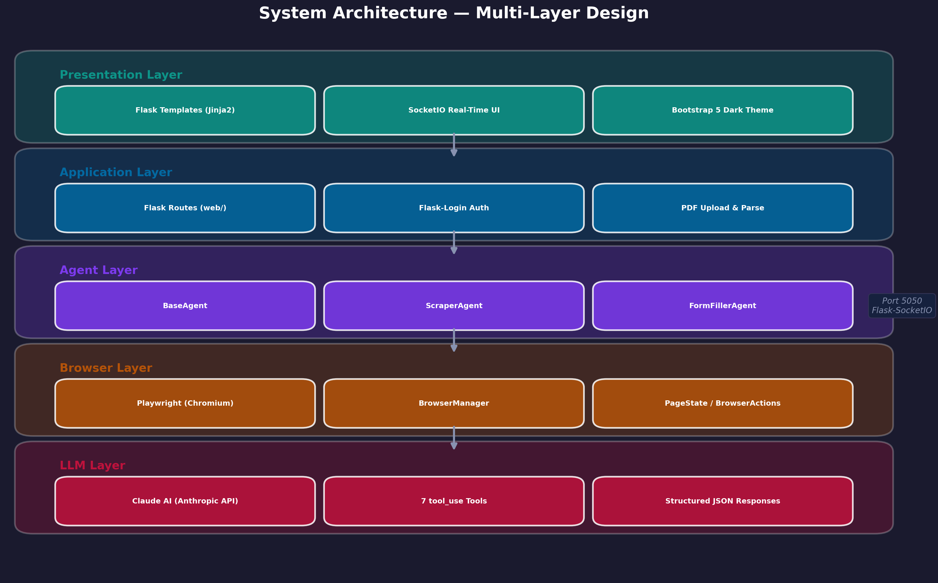
Fig 3.1: System Architecture Diagram
3.3 UML Diagrams
3.3.1 Use Case Diagram
The use case diagram illustrates the interactions between the primary actor (User) and the system's functional capabilities. The user can register a new account, log in with credentials, initiate web scraping tasks by providing a URL and extraction prompt, upload PDF resumes for form filling, start and stop automation sessions, view live progress through real-time screenshots, download extracted data, and review task history.
The system actor (Claude AI) participates as an internal agent that receives page state information, reasons about the appropriate next action, and returns structured tool calls. The Playwright browser acts as another system actor that executes browser commands and captures page screenshots. The diagram shows that authentication is a prerequisite for all automation use cases, enforced through Flask-Login middleware.
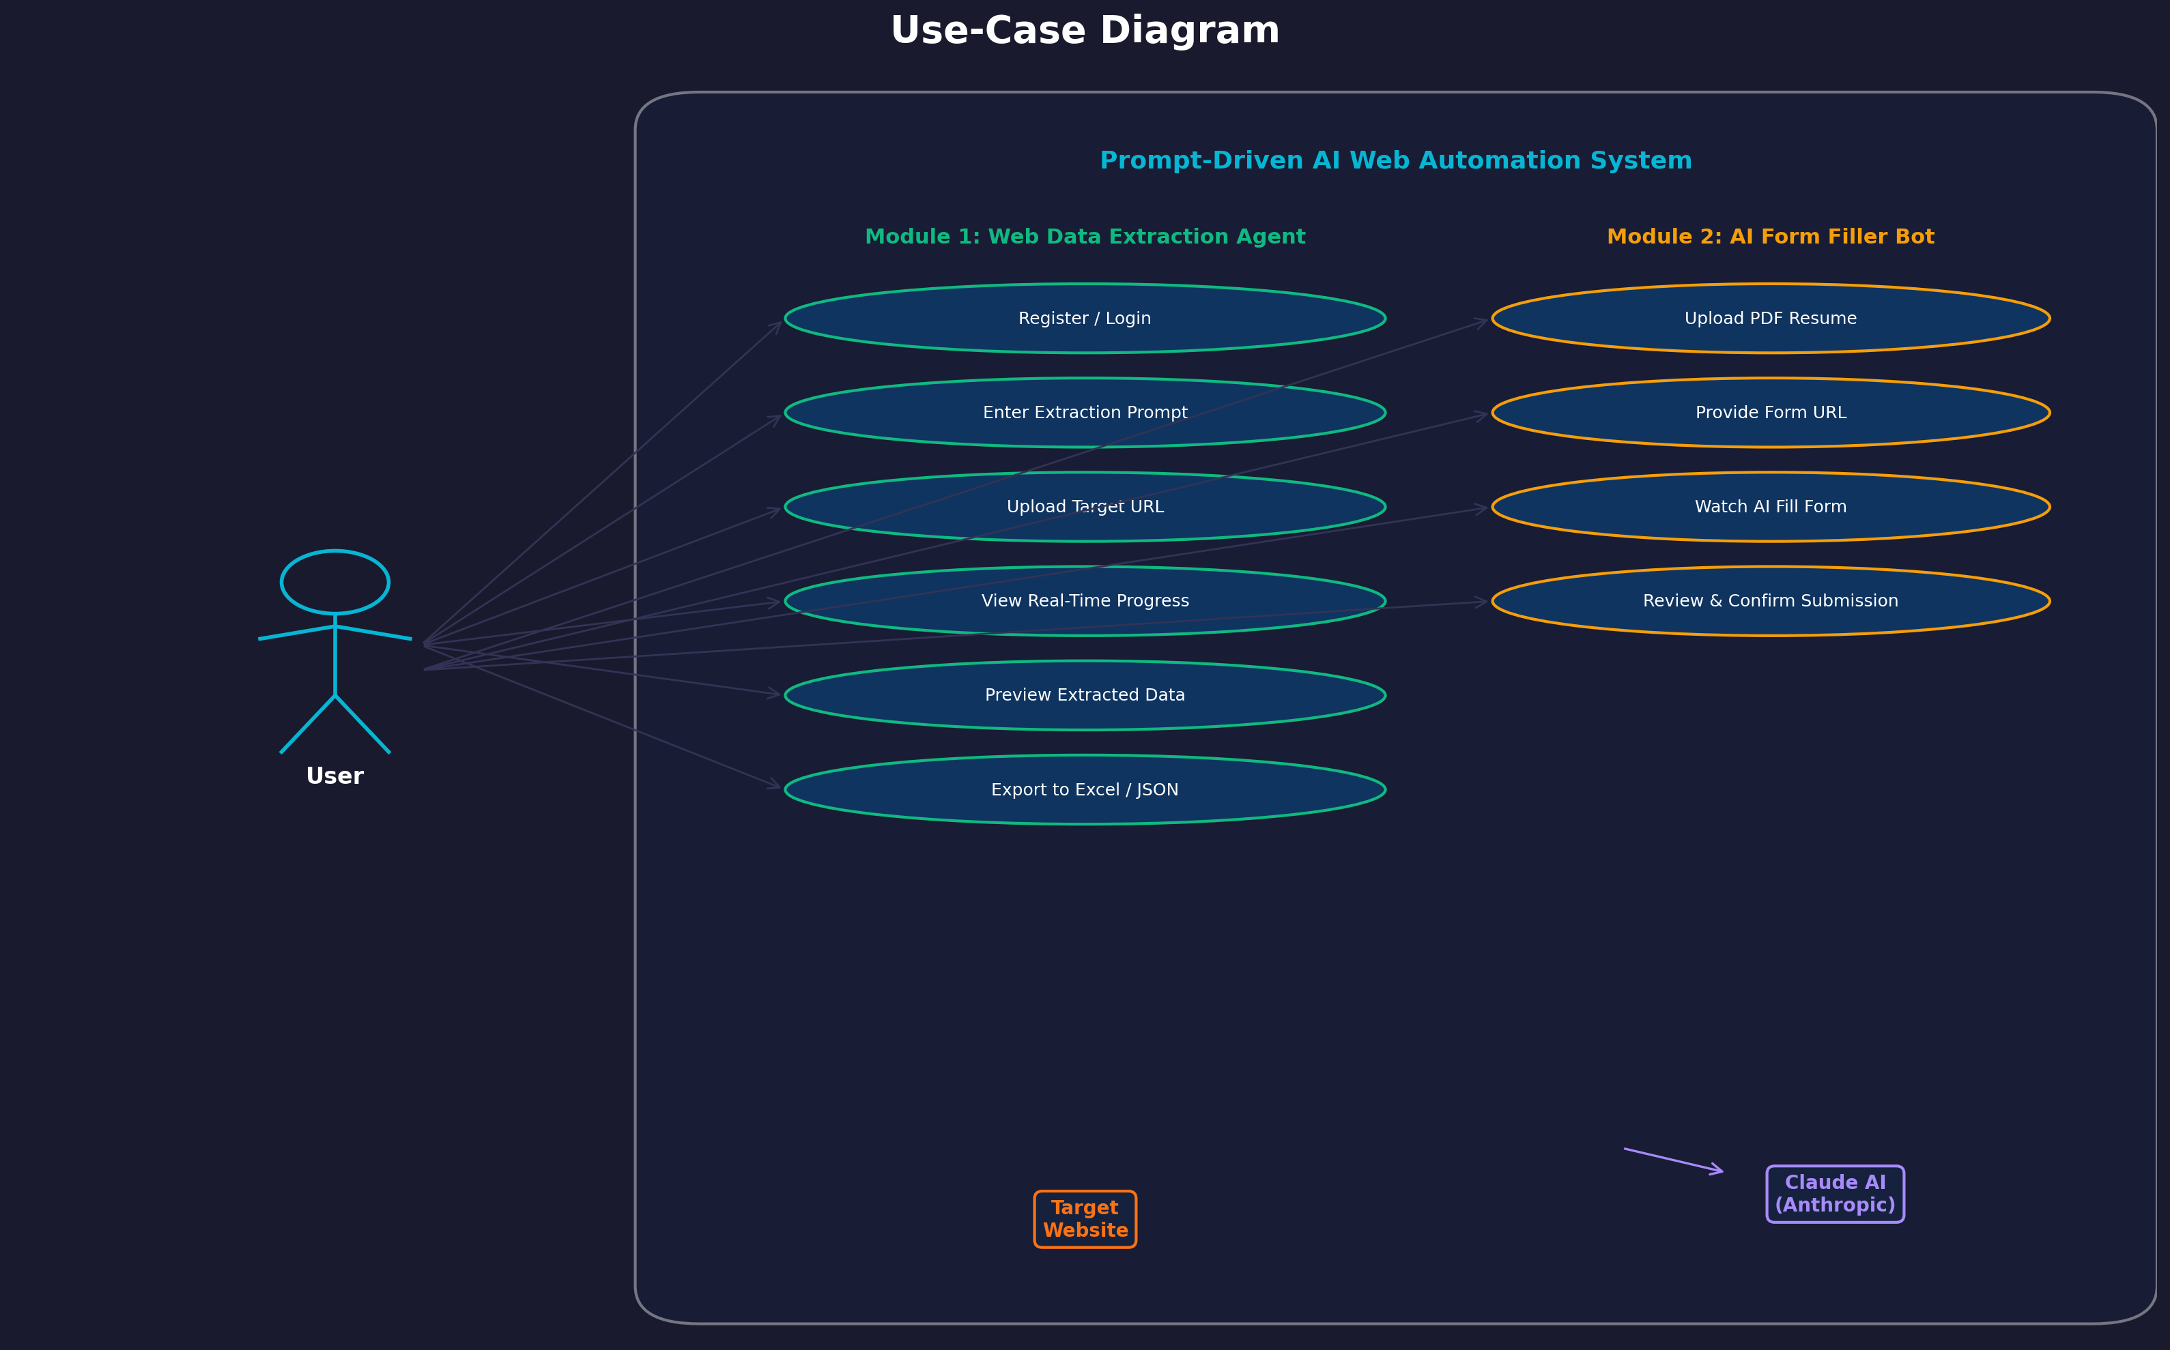
Fig 3.2: Use Case Diagram
3.3.2 Class Diagram
The class diagram depicts the object-oriented structure of the system's core modules. The BaseAgent abstract base class defines the common interface for all agents, including methods for initializing browser sessions, executing automation loops, and emitting SocketIO events. ScraperAgent and FormFillerAgent extend BaseAgent with module-specific implementations. ScraperAgent includes methods for data extraction and Excel export, while FormFillerAgent handles PDF parsing, resume data structuring, and form field mapping.
The BrowserManager class encapsulates Playwright's browser lifecycle — launching, creating contexts, managing pages, and cleanup. PageState is a data class that captures the current state of a browser page including URL, title, visible text content, and a base64-encoded screenshot. BrowserActions provides static methods for each browser operation (click, fill, select, navigate, scroll). ClaudeClient manages communication with the Anthropic API, formatting tool definitions and parsing tool_use responses. The PDFParser and ExcelExporter utility classes handle document processing and data export respectively.
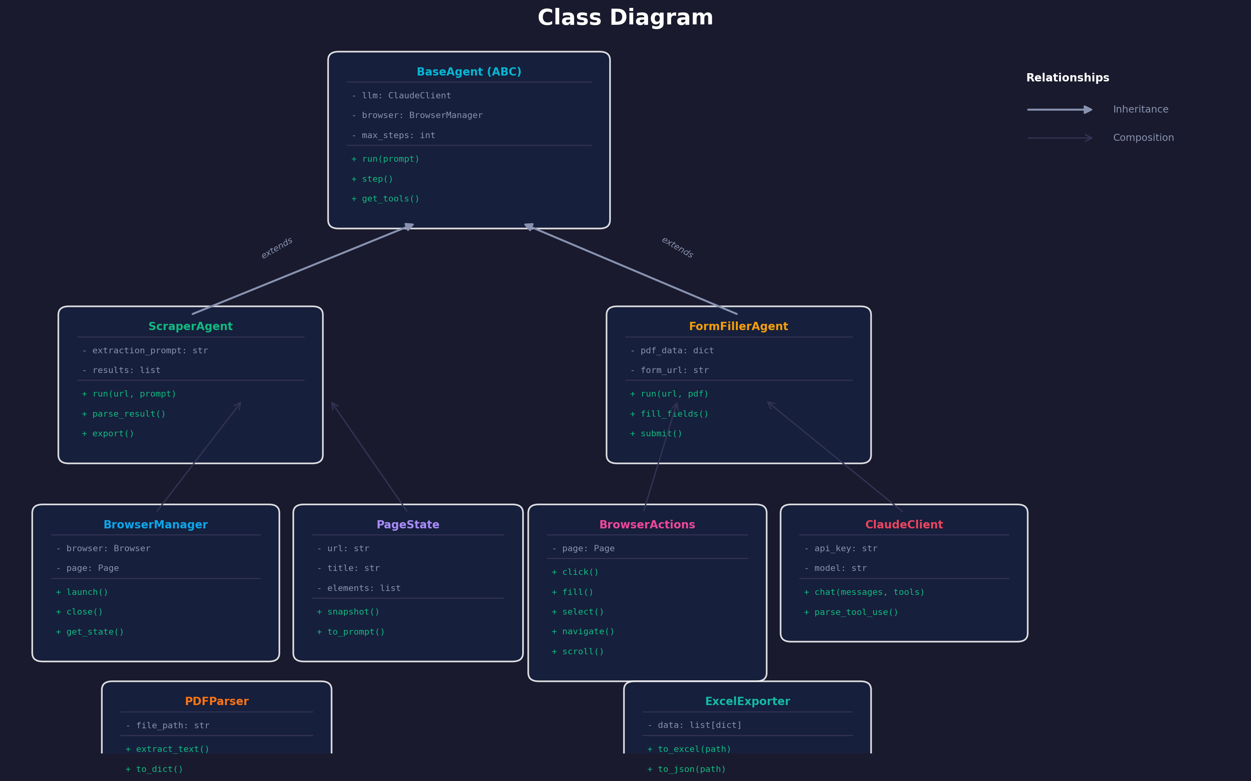
Fig 3.3: Class Diagram
3.3.3 Sequence Diagram
The sequence diagram illustrates the end-to-end flow of an automation task. The user submits a task through the web interface, which sends an HTTP request to the Flask backend. The appropriate agent (ScraperAgent or FormFillerAgent) is instantiated and begins the automation loop. In each iteration, the agent captures the current PageState via BrowserManager, sends it to ClaudeClient along with the task description, and receives a tool_use response specifying the next action.
The agent then executes the specified tool call through BrowserActions (e.g., click a button, fill a text field, navigate to a URL). After execution, the agent captures an updated screenshot and emits it to the frontend via SocketIO along with a color-coded action log entry. This loop continues until Claude returns the 'done' tool indicating task completion, or until the maximum step limit (MAX_AGENT_STEPS=25) is reached. The final results are then packaged and made available for download.
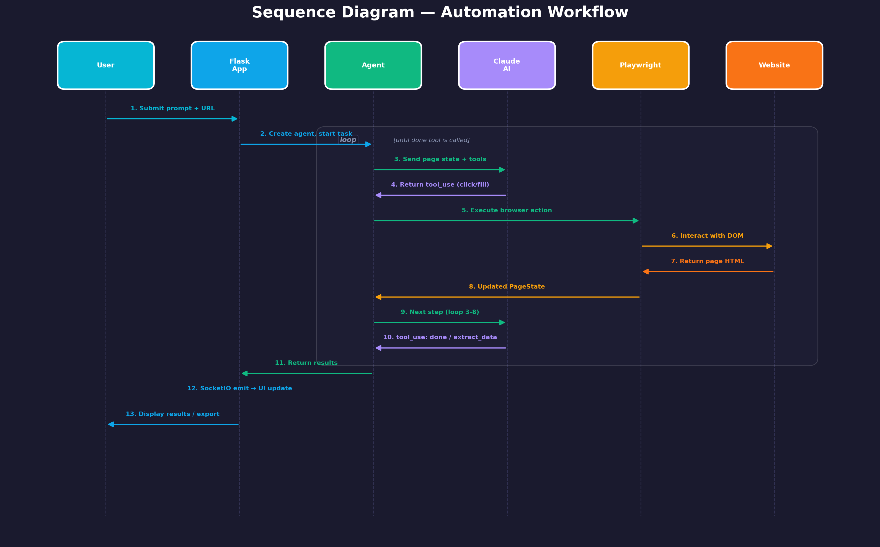
Fig 3.4: Sequence Diagram
3.3.4 Activity Diagram
The activity diagram models the workflow of the automation process from task initiation to completion. The flow begins with user authentication, followed by module selection (scraper or form filler). For the scraper module, the user provides a target URL and extraction prompt. For the form filler, the user uploads a PDF resume and specifies the target form URL. The system then launches a Playwright browser instance and begins the agent loop.
Within the agent loop, the activity diagram shows a decision point at each step: capture page state, send to Claude AI, receive tool call, execute action, check if the task is complete. If complete (Claude returns 'done' tool) or if the step limit is reached, the loop exits. The final activities include generating output files (Excel for scraper, logs for form filler), saving task history, and displaying results to the user through the web interface.
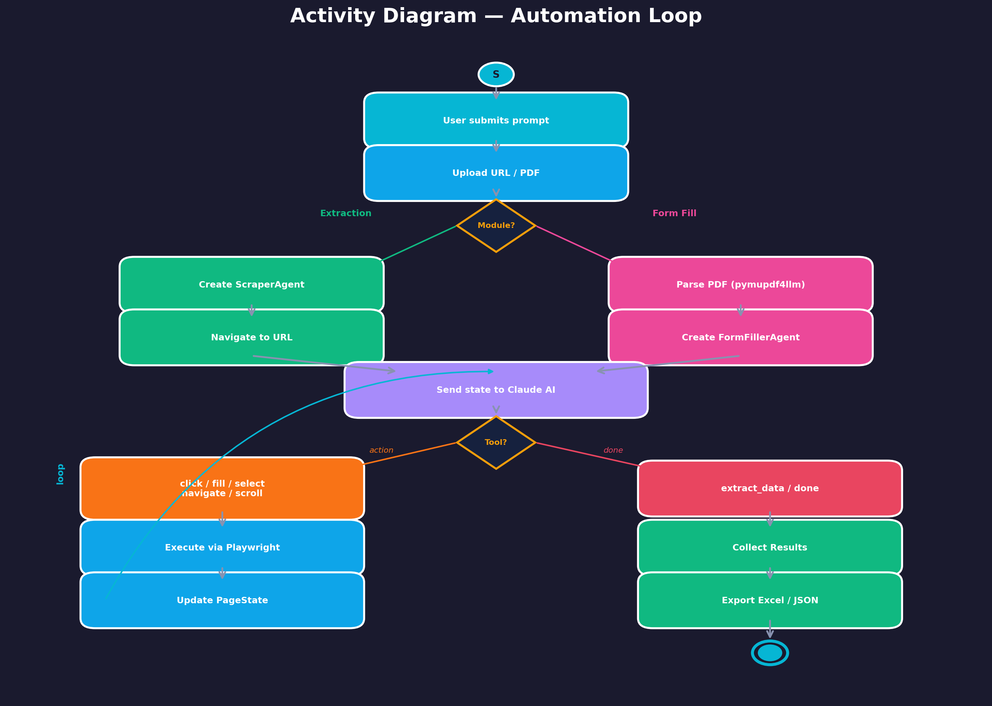
Fig 3.5: Activity Diagram
3.4 Database Design
3.4.1 ER Diagram
The database design for this project is intentionally minimal, as the primary data processing occurs in-memory during automation sessions and results are exported to files. The SQLite database (auth.db) stores user authentication data in a single 'users' table. The ER diagram shows the User entity with attributes for id (primary key), username (unique), password_hash, and created_at timestamp.
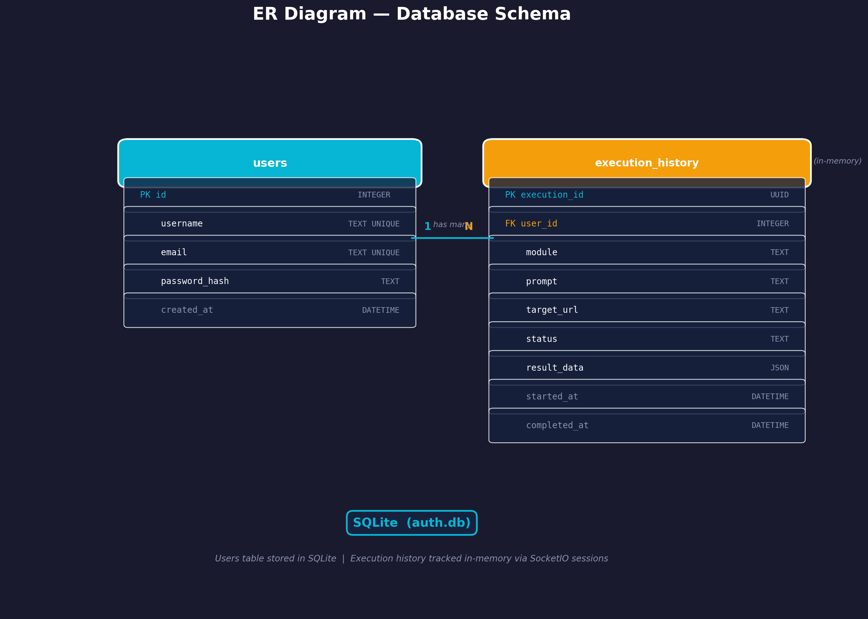
Fig 3.6: Entity-Relationship Diagram
3.4.2 Database Tables
The system uses a single database table named 'users' within the SQLite database file 'auth.db'. The table stores user credentials for the authentication system. The 'id' column serves as the auto-incrementing primary key. The 'username' column stores the unique login identifier and is indexed for fast lookup. The 'password_hash' column stores Werkzeug-generated password hashes for secure credential storage. The 'created_at' column records the account creation timestamp with a default value of the current UTC time.
CHAPTER 4
IMPLEMENTATION
4.1 Development Methodology
The project was developed using the Agile software development methodology, which emphasizes iterative development, continuous feedback, and adaptive planning. The development was organized into five sprints, each spanning approximately two to three weeks. Sprint 1 established the project foundation including Flask application setup, directory structure, configuration management, SQLite database initialization, and the user authentication system. Sprint 2 focused on integrating Playwright for browser automation, implementing the BrowserManager class, and building the core BrowserActions module.
Sprint 3 was dedicated to Claude AI integration through the Anthropic SDK, defining the seven tool schemas, implementing the ClaudeClient class, and building the ScraperAgent with its extraction and export capabilities. Sprint 4 covered the FormFillerAgent implementation, PDF resume parsing with pymupdf4llm, and the resume data mapping logic. Sprint 5 addressed SocketIO real-time streaming integration, frontend UI development with Bootstrap 5, comprehensive testing, and project documentation. This iterative approach enabled early detection of integration issues and continuous refinement of the AI agent's behavior.
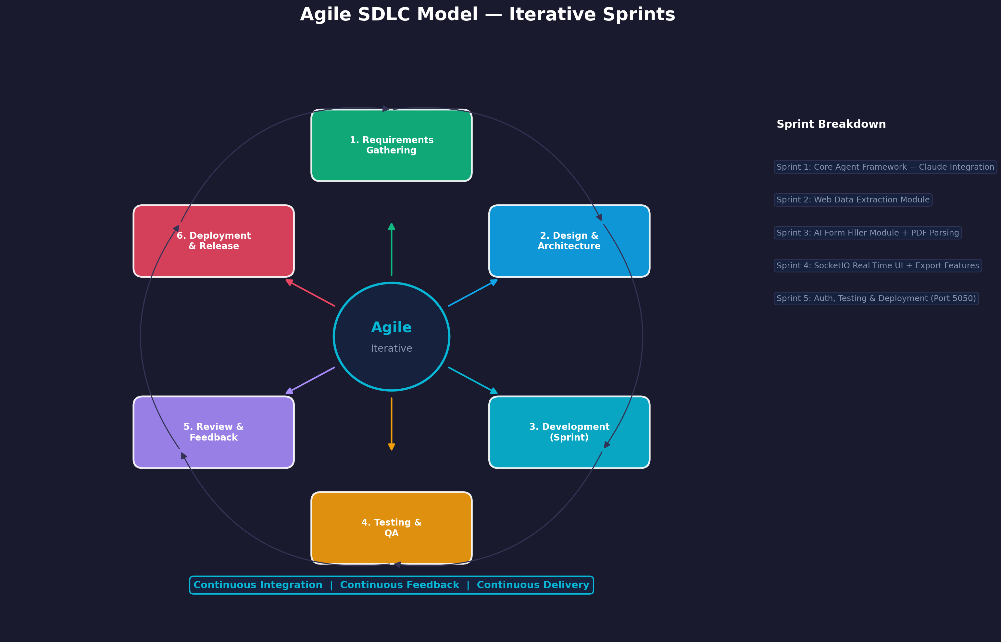
Fig 4.1: Agile Development Model
4.2 Technology Stack
Table 4.1: Technology Stack
S.No | Category | Technology | Version | Purpose
1 | Language | Python | 3.10+ | Backend development and scripting
2 | Web Framework | Flask | 3.1 | HTTP routing and request handling
3 | Real-Time | Flask-SocketIO | 5.4.1 | WebSocket-based live streaming
4 | AI/LLM | Anthropic SDK (Claude) | Latest | LLM reasoning and tool_use
5 | Browser Automation | Playwright | 1.49.1 | Chromium browser control
6 | Authentication | Flask-Login | Latest | Session management and auth
7 | Database | SQLite | 3.x | User credentials storage
8 | PDF Parsing | pymupdf4llm | Latest | PDF resume text extraction
9 | Data Export | pandas + openpyxl | Latest | DataFrame to Excel export
10 | Frontend | Bootstrap | 5.3.3 | Responsive UI components
11 | Templating | Jinja2 | 3.x | Server-side HTML rendering
12 | Password Hashing | Werkzeug | Latest | Secure credential storage
4.3 Flask Application Routes
Table 4.2: Application Routes
S.No | URL | Method | Auth | Purpose
1 | / | GET | Yes | Dashboard / index page
2 | /auth/login | GET, POST | No | User login page and handler
3 | /auth/register | GET, POST | No | User registration page and handler
4 | /auth/logout | GET | Yes | Log out current user
5 | /scraper | GET | Yes | Web scraper interface page
6 | /scraper/start | POST | Yes | Start scraping task with URL and prompt
7 | /scraper/stop | POST | Yes | Stop running scraping task
8 | /scraper/download/<filename> | GET | Yes | Download scraped Excel file
9 | /form-filler | GET | Yes | Form filler interface page
10 | /form-filler/upload-resume | POST | Yes | Upload and parse PDF resume
11 | /form-filler/start | POST | Yes | Start form filling automation
12 | /form-filler/stop | POST | Yes | Stop running form fill task
13 | /form-filler/demo-form | GET | No | Demo form for testing form filler
14 | /history | GET | Yes | Task history page
15 | /api/history | GET | Yes | JSON API for task history data
16 | /api/history/clear | POST | Yes | Clear all task history
4.4 Database Schema
Table 4.3: Users Table Schema
Column | Type | Constraints | Description
id | INTEGER | PRIMARY KEY, AUTOINCREMENT | Unique user identifier
username | TEXT | NOT NULL, UNIQUE | Login username
password_hash | TEXT | NOT NULL | Werkzeug-generated password hash
created_at | TIMESTAMP | DEFAULT CURRENT_TIMESTAMP | Account creation date and time
4.5 Core Module Implementation
4.5.1 Agent Architecture
The agent architecture is built around the BaseAgent abstract base class, which defines the common interface and shared behavior for all automation agents. BaseAgent provides methods for initializing Playwright browser sessions, executing the main automation loop, emitting SocketIO events for real-time updates, and managing the step counter against the configured MAX_AGENT_STEPS limit. It also handles graceful shutdown and resource cleanup when a task completes or is stopped by the user.
ScraperAgent extends BaseAgent to implement web data extraction. It overrides the task execution method to navigate to a target URL, send the page state and extraction prompt to Claude AI, and iteratively follow Claude's tool_use instructions until the 'extract_data' or 'done' tool is invoked. Extracted data is structured into a pandas DataFrame and exported to Excel format using openpyxl.
FormFillerAgent extends BaseAgent to implement automated form filling. It first processes the uploaded PDF resume through the PDFParser to extract structured personal and professional information. It then navigates to the target form URL and provides Claude AI with both the page state and the parsed resume data. Claude determines which form fields to fill, what values to enter, and the sequence of interactions required to complete the form.
4.5.2 Claude AI Integration
The Claude AI integration is managed through the ClaudeClient class, which wraps the Anthropic SDK to provide a clean interface for the agent classes. The client formats requests with a system prompt describing the automation context, the current page state (URL, title, visible text excerpt, and base64 screenshot), the user's task description, and the conversation history. It sends these to the Claude API with the tool definitions, requesting Claude to respond with structured tool_use calls.
Seven tools are defined for Claude's use: 'click' (selector-based element clicking), 'fill' (typing text into input fields), 'select_option' (choosing dropdown values), 'navigate' (going to a URL), 'scroll' (scrolling the page up or down), 'extract_data' (extracting structured data from the current page), and 'done' (signaling task completion with a summary). Each tool definition includes a JSON schema specifying the expected parameters, enabling Claude to generate well-structured tool calls.
The response parsing logic handles both tool_use and text responses. When Claude returns a tool_use block, the client extracts the tool name and arguments, validates them against the schema, and returns them to the agent for execution. The conversation history is maintained across steps to provide Claude with context about previous actions and their outcomes, enabling more informed decision-making in subsequent steps.
4.5.3 Playwright Browser Automation
The Playwright integration is structured around two classes: BrowserManager and BrowserActions. BrowserManager handles the browser lifecycle — launching a Chromium instance, creating browser contexts with appropriate viewport settings, opening new pages, and performing cleanup on task completion or cancellation. It operates in headless mode by default for server deployment but can be configured for headed mode during development.
BrowserActions provides static methods corresponding to each of Claude's tool definitions. The 'click' action locates elements using CSS selectors or text content and performs click interactions. The 'fill' action clears existing input values and types new text. The 'select_option' action handles dropdown selections by value or visible text. The 'navigate' action directs the browser to a specified URL and waits for the page to load. The 'scroll' action scrolls the page by a specified pixel amount in either direction.
The PageState data class captures a comprehensive snapshot of the current browser page at each step. It includes the page URL, document title, visible text content (truncated to a reasonable length for the LLM context window), and a base64-encoded JPEG screenshot. This screenshot serves dual purposes: it is sent to Claude AI as visual context for decision-making and simultaneously streamed to the user's browser via SocketIO for real-time monitoring.
4.5.4 PDF Parsing
The PDFParser class utilizes the pymupdf4llm library to extract text content from uploaded PDF resumes in a format optimized for large language model consumption. The library converts PDF pages into structured markdown text, preserving headings, paragraphs, lists, and formatting cues that help Claude AI understand the document's structure and extract relevant fields such as name, email, phone number, education, experience, and skills.
The parsed resume text is then sent to Claude AI along with a structured extraction prompt that requests specific fields in JSON format. Claude processes the unstructured resume text and returns a structured dictionary mapping field names to values, which the FormFillerAgent uses as the data source when filling web forms.
4.5.5 Excel Export
The ExcelExporter class handles the conversion of scraped data into downloadable Excel files. When the ScraperAgent's 'extract_data' tool is invoked by Claude, the extracted data — typically a list of dictionaries — is converted into a pandas DataFrame. The DataFrame is then exported to an Excel file using the openpyxl engine, with auto-adjusted column widths and formatted headers for readability.
The exported files are saved with unique timestamps in the filename to prevent overwrites and are served through the /scraper/download/<filename> route. This approach ensures that users can download their results at any time and that multiple scraping sessions produce distinct output files.
4.5.6 Real-Time SocketIO Streaming
Flask-SocketIO 5.4.1 enables real-time bidirectional communication between the Flask backend and the user's browser. When an automation task is running, the agent emits two types of events at each step: a 'screenshot' event containing the base64-encoded JPEG image of the current browser page, and a 'log' event containing a color-coded action message describing what the AI agent just did (e.g., 'Clicked on Submit button', 'Filled email field with user@example.com').
The frontend JavaScript client listens for these events and updates the UI in real time. Screenshots are displayed in an image element that refreshes with each new frame, creating a live view of the automated browser. Action logs are appended to a scrollable log panel with color coding — blue for navigation, green for successful actions, yellow for warnings, and red for errors. This real-time feedback mechanism provides users with full transparency into the AI agent's behavior and decision-making process.
4.6 Authentication System
The authentication system is built on Flask-Login, providing session-based user management. Users register with a username and password; the password is hashed using Werkzeug's generate_password_hash function before storage in the SQLite database. During login, the submitted password is verified against the stored hash using check_password_hash. Successful authentication creates a Flask session, and the @login_required decorator protects all automation routes.
The User model class implements Flask-Login's UserMixin interface, providing properties for is_authenticated, is_active, is_anonymous, and get_id. The user_loader callback retrieves user objects from the database by ID for session reconstruction. Authentication routes are organized in a dedicated Blueprint (auth_bp) to maintain clean separation from the main application routes.
4.7 Frontend Implementation
The frontend is built using Bootstrap 5.3.3 with a Chrome-inspired light theme. The design uses a primary accent color of #1a73e8 (Google Blue) against a light gray (#f1f3f4) background, creating a clean and modern aesthetic. The layout features a fixed navigation bar with module links, a responsive content area, and module-specific interfaces for the scraper and form filler. Jinja2 templates extend a base layout template that includes common elements such as navigation, footer, and SocketIO client scripts.
Each automation module's interface is divided into a control panel on the left (for input parameters and action buttons) and a live monitoring panel on the right (for real-time screenshots and action logs). The scraper interface includes fields for the target URL and extraction prompt, start/stop buttons, and a download section for results. The form filler interface includes a resume upload area, form URL field, start/stop controls, and the live view panel. The demo form route (/form-filler/demo-form) provides a sample form for testing the form filler functionality without requiring an external website.
CHAPTER 5
SOURCE CODE
5.1 Project Structure
The following directory tree shows the organization of the project codebase:
prompt-web-automation/
|-- app.py # Application entry point
|-- config.py # Configuration settings
|-- requirements.txt # Python dependencies
|-- auth.db # SQLite database (auto-created)
|-- core/
| |-- __init__.py
| |-- agents/
| | |-- __init__.py
| | |-- base_agent.py # Abstract base agent class
| | |-- scraper_agent.py # Web data extraction agent
| | |-- form_filler_agent.py # AI form filler agent
| |-- browser/
| | |-- __init__.py
| | |-- manager.py # Playwright browser manager
| | |-- actions.py # Browser action implementations
| | |-- page_state.py # Page state data class
| |-- llm/
| | |-- __init__.py
| | |-- claude_client.py # Claude AI API client
| | |-- tools.py # Tool definitions for Claude
| |-- utils/
| |-- __init__.py
| |-- pdf_parser.py # PDF resume parser
| |-- excel_exporter.py # Excel file exporter
|-- web/
| |-- __init__.py
| |-- routes/
| | |-- __init__.py
| | |-- auth.py # Authentication routes
| | |-- scraper.py # Scraper routes
| | |-- form_filler.py # Form filler routes
| | |-- history.py # History routes
|-- templates/
| |-- base.html # Base layout template
| |-- index.html # Dashboard page
| |-- auth/
| | |-- login.html
| | |-- register.html
| |-- scraper.html # Scraper interface
| |-- form_filler.html # Form filler interface
| |-- demo_form.html # Demo form for testing
| |-- history.html # Task history page
|-- static/
| |-- css/
| | |-- style.css # Custom styles
| |-- js/
| |-- scraper.js # Scraper client-side logic
| |-- form_filler.js # Form filler client-side logic
|-- exports/ # Exported Excel files
|-- uploads/ # Uploaded PDF resumes
5.2 Configuration (config.py)
import os

class Config:
SECRET_KEY = os.environ.get('SECRET_KEY', 'dev-secret-key-change-in-production')
DATABASE_PATH = os.path.join(os.path.dirname(__file__), 'auth.db')
UPLOAD_FOLDER = os.path.join(os.path.dirname(__file__), 'uploads')
EXPORT_FOLDER = os.path.join(os.path.dirname(__file__), 'exports')

# Claude AI Configuration
CLAUDE_API_KEY = os.environ.get('ANTHROPIC_API_KEY', '')
CLAUDE_MODEL = 'claude-sonnet-4-20250514'

# Agent Configuration
MAX_AGENT_STEPS = 25
STEP_DELAY = 1.0

# Browser Configuration
HEADLESS = True
VIEWPORT_WIDTH = 1280
VIEWPORT_HEIGHT = 720
5.3 Application Entry Point (app.py)
import os
from flask import Flask
from flask_socketio import SocketIO
from flask_login import LoginManager
from config import Config

socketio = SocketIO()
login_manager = LoginManager()

def create_app():
app = Flask(__name__)
app.config.from_object(Config)

# Ensure directories exist
os.makedirs(app.config['UPLOAD_FOLDER'], exist_ok=True)
os.makedirs(app.config['EXPORT_FOLDER'], exist_ok=True)

# Initialize extensions
socketio.init_app(app, cors_allowed_origins="*")
login_manager.init_app(app)
login_manager.login_view = 'auth.login'

# Initialize database
from web.routes.auth import init_db, load_user
init_db(app.config['DATABASE_PATH'])
login_manager.user_loader(load_user)

# Register blueprints
from web.routes.auth import auth_bp
from web.routes.scraper import scraper_bp
from web.routes.form_filler import form_filler_bp
from web.routes.history import history_bp

app.register_blueprint(auth_bp)
app.register_blueprint(scraper_bp)
app.register_blueprint(form_filler_bp)
app.register_blueprint(history_bp)

@app.route('/')
def index():
return render_template('index.html')

return app

if __name__ == '__main__':
app = create_app()
socketio.run(app, host='0.0.0.0', port=5050, debug=True)
5.4 Authentication Routes (web/routes/auth.py)
import sqlite3
from flask import Blueprint, render_template, request, redirect, url_for, flash
from flask_login import login_user, logout_user, login_required, UserMixin
from werkzeug.security import generate_password_hash, check_password_hash

auth_bp = Blueprint('auth', __name__, url_prefix='/auth')
DB_PATH = None

class User(UserMixin):
def __init__(self, id, username):
self.id = id
self.username = username

def init_db(db_path):
global DB_PATH
DB_PATH = db_path
conn = sqlite3.connect(db_path)
conn.execute('''CREATE TABLE IF NOT EXISTS users (
id INTEGER PRIMARY KEY AUTOINCREMENT,
username TEXT NOT NULL UNIQUE,
password_hash TEXT NOT NULL,
created_at TIMESTAMP DEFAULT CURRENT_TIMESTAMP
)''')
conn.commit()
conn.close()

def load_user(user_id):
conn = sqlite3.connect(DB_PATH)
row = conn.execute('SELECT id, username FROM users WHERE id=?',
(user_id,)).fetchone()
conn.close()
return User(row[0], row[1]) if row else None

@auth_bp.route('/login', methods=['GET', 'POST'])
def login():
if request.method == 'POST':
username = request.form.get('username', '').strip()
password = request.form.get('password', '')
conn = sqlite3.connect(DB_PATH)
row = conn.execute('SELECT id, username, password_hash FROM users WHERE username=?',
(username,)).fetchone()
conn.close()
if row and check_password_hash(row[2], password):
login_user(User(row[0], row[1]))
return redirect(url_for('index'))
flash('Invalid username or password', 'danger')
return render_template('auth/login.html')

@auth_bp.route('/register', methods=['GET', 'POST'])
def register():
if request.method == 'POST':
username = request.form.get('username', '').strip()
password = request.form.get('password', '')
if not username or not password:
flash('Username and password are required', 'danger')
else:
conn = sqlite3.connect(DB_PATH)
try:
conn.execute('INSERT INTO users (username, password_hash) VALUES (?, ?)',
(username, generate_password_hash(password)))
conn.commit()
flash('Registration successful! Please log in.', 'success')
return redirect(url_for('auth.login'))
except sqlite3.IntegrityError:
flash('Username already exists', 'danger')
finally:
conn.close()
return render_template('auth/register.html')

@auth_bp.route('/logout')
@login_required
def logout():
logout_user()
return redirect(url_for('auth.login'))
5.5 Scraper Agent (core/agents/scraper_agent.py)
from core.agents.base_agent import BaseAgent
from core.utils.excel_exporter import ExcelExporter

class ScraperAgent(BaseAgent):
def __init__(self, socketio, sid):
super().__init__(socketio, sid)
self.extracted_data = None

def get_system_prompt(self):
return (
"You are a web scraping agent. Your task is to navigate websites "
"and extract structured data as requested by the user. Use the "
"provided tools to interact with the page. When you have found "
"and extracted the requested data, use the extract_data tool to "
"return it as structured JSON, then use the done tool."
)

async def execute_task(self, url, prompt):
try:
await self.start_browser()
self.emit_log('info', f'Navigating to {url}')
await self.page.goto(url, wait_until='domcontentloaded')
await self.run_agent_loop(prompt)

if self.extracted_data:
filename = ExcelExporter.export(self.extracted_data)
self.emit_log('success', f'Data exported to {filename}')
return {'status': 'success', 'filename': filename}
return {'status': 'completed', 'message': 'Task completed'}
except Exception as e:
self.emit_log('error', f'Error: {str(e)}')
return {'status': 'error', 'message': str(e)}
finally:
await self.stop_browser()

def handle_tool_result(self, tool_name, tool_args, result):
if tool_name == 'extract_data':
self.extracted_data = tool_args.get('data', [])
self.emit_log('success', f'Extracted {len(self.extracted_data)} records')
5.6 Form Filler Agent (core/agents/form_filler_agent.py)
from core.agents.base_agent import BaseAgent
from core.utils.pdf_parser import PDFParser

class FormFillerAgent(BaseAgent):
def __init__(self, socketio, sid):
super().__init__(socketio, sid)
self.resume_data = None

def get_system_prompt(self):
resume_context = ""
if self.resume_data:
resume_context = f"\nResume data available:\n{self.resume_data}"
return (
"You are a form filling agent. Your task is to fill out web forms "
"using the provided resume/personal data. Analyze the form fields, "
"match them with the available data, and fill each field accurately. "
"Use the fill tool for text inputs, select_option for dropdowns, "
"and click for checkboxes/radio buttons and submit buttons."
f"{resume_context}"
)

async def parse_resume(self, pdf_path):
parser = PDFParser()
self.resume_data = parser.parse(pdf_path)
self.emit_log('info', f'Resume parsed: {len(self.resume_data)} fields extracted')
return self.resume_data

async def execute_task(self, url, resume_data=None):
try:
if resume_data:
self.resume_data = resume_data
await self.start_browser()
self.emit_log('info', f'Navigating to form: {url}')
await self.page.goto(url, wait_until='domcontentloaded')
await self.run_agent_loop("Fill out this form using the resume data provided.")
return {'status': 'success', 'message': 'Form filling completed'}
except Exception as e:
self.emit_log('error', f'Error: {str(e)}')
return {'status': 'error', 'message': str(e)}
finally:
await self.stop_browser()
5.7 Claude Client (core/llm/claude_client.py)
import anthropic
from config import Config
from core.llm.tools import TOOL_DEFINITIONS

class ClaudeClient:
def __init__(self):
self.client = anthropic.Anthropic(api_key=Config.CLAUDE_API_KEY)
self.model = Config.CLAUDE_MODEL
self.conversation_history = []

def reset(self):
self.conversation_history = []

def get_next_action(self, system_prompt, page_state, task_description):
messages = list(self.conversation_history)

user_content = [
{"type": "text", "text": f"Task: {task_description}"},
{"type": "text", "text": f"Current URL: {page_state.url}"},
{"type": "text", "text": f"Page Title: {page_state.title}"},
{"type": "text", "text": f"Visible Text:\n{page_state.text[:3000]}"},
]
if page_state.screenshot:
user_content.append({
"type": "image",
"source": {
"type": "base64",
"media_type": "image/jpeg",
"data": page_state.screenshot
}
})

messages.append({"role": "user", "content": user_content})

response = self.client.messages.create(
model=self.model,
max_tokens=1024,
system=system_prompt,
tools=TOOL_DEFINITIONS,
messages=messages
)

# Parse tool_use response
for block in response.content:
if block.type == "tool_use":
self.conversation_history = messages
self.conversation_history.append({
"role": "assistant", "content": response.content
})
return {
"tool": block.name,
"args": block.input,
"id": block.id
}

return {"tool": "done", "args": {"summary": "No tool call received"}}
5.8 Browser Manager (core/browser/manager.py)
import asyncio
import base64
from playwright.async_api import async_playwright
from config import Config
from core.browser.page_state import PageState

class BrowserManager:
def __init__(self):
self.playwright = None
self.browser = None
self.context = None
self.page = None

async def start(self):
self.playwright = await async_playwright().start()
self.browser = await self.playwright.chromium.launch(
headless=Config.HEADLESS
)
self.context = await self.browser.new_context(
viewport={
'width': Config.VIEWPORT_WIDTH,
'height': Config.VIEWPORT_HEIGHT
}
)
self.page = await self.context.new_page()
return self.page

async def get_page_state(self):
screenshot_bytes = await self.page.screenshot(type='jpeg', quality=50)
screenshot_b64 = base64.b64encode(screenshot_bytes).decode('utf-8')

try:
text = await self.page.inner_text('body', timeout=3000)
except Exception:
text = ""

return PageState(
url=self.page.url,
title=await self.page.title(),
text=text[:5000],
screenshot=screenshot_b64
)

async def stop(self):
if self.context:
await self.context.close()
if self.browser:
await self.browser.close()
if self.playwright:
await self.playwright.stop()
self.page = None
self.context = None
self.browser = None
self.playwright = None
5.9 Tool Definitions (core/llm/tools.py)
TOOL_DEFINITIONS = [
{
"name": "click",
"description": "Click on an element on the page identified by CSS selector or text.",
"input_schema": {
"type": "object",
"properties": {
"selector": {"type": "string", "description": "CSS selector or text of element"},
},
"required": ["selector"]
}
},
{
"name": "fill",
"description": "Fill a text input or textarea with the specified value.",
"input_schema": {
"type": "object",
"properties": {
"selector": {"type": "string", "description": "CSS selector of the input field"},
"value": {"type": "string", "description": "Text value to enter"}
},
"required": ["selector", "value"]
}
},
{
"name": "select_option",
"description": "Select an option from a dropdown/select element.",
"input_schema": {
"type": "object",
"properties": {
"selector": {"type": "string", "description": "CSS selector of the select element"},
"value": {"type": "string", "description": "Option value or visible text"}
},
"required": ["selector", "value"]
}
},
{
"name": "navigate",
"description": "Navigate the browser to a specified URL.",
"input_schema": {
"type": "object",
"properties": {
"url": {"type": "string", "description": "URL to navigate to"}
},
"required": ["url"]
}
},
{
"name": "scroll",
"description": "Scroll the page up or down by a specified amount.",
"input_schema": {
"type": "object",
"properties": {
"direction": {"type": "string", "enum": ["up", "down"]},
"amount": {"type": "integer", "description": "Pixels to scroll", "default": 500}
},
"required": ["direction"]
}
},
{
"name": "extract_data",
"description": "Extract structured data from the current page.",
"input_schema": {
"type": "object",
"properties": {
"data": {
"type": "array",
"items": {"type": "object"},
"description": "Array of extracted data objects"
}
},
"required": ["data"]
}
},
{
"name": "done",
"description": "Signal that the task is complete.",
"input_schema": {
"type": "object",
"properties": {
"summary": {"type": "string", "description": "Summary of what was accomplished"}
},
"required": ["summary"]
}
}
]
CHAPTER 6
TESTING
6.1 Testing Strategy
A comprehensive testing strategy was employed to ensure the reliability, correctness, and performance of the Prompt-Driven AI Web Automation system. The testing approach encompassed four levels: unit testing of individual modules, integration testing of end-to-end workflows, performance testing under various load conditions, and security testing of authentication and data protection mechanisms.
Unit tests were designed to verify the behavior of individual components in isolation, including authentication handlers, agent initialization, browser action execution, and data export functions. Integration tests validated the complete workflow from user input through AI processing to browser action and result delivery. Performance tests measured response times, concurrent connection handling, and automation task throughput. Security tests assessed the robustness of the authentication system, input validation, and API key protection mechanisms.
6.2 Unit Testing
Table 6.1: Unit Test Cases
Test ID | Module | Test Description | Input | Expected Output | Status
UT-01 | Auth | Valid user login | Correct username and password | Redirect to dashboard with session | Pass
UT-02 | Auth | Invalid login attempt | Wrong password | Error flash message displayed | Pass
UT-03 | Auth | New user registration | Unique username and password | Account created, redirect to login | Pass
UT-04 | Auth | Duplicate registration | Existing username | Error: username already exists | Pass
UT-05 | Scraper | Start scraping task | Valid URL and extraction prompt | Browser launches, agent loop starts | Pass
UT-06 | Scraper | Stop running task | Stop button clicked | Browser closes, task terminated cleanly | Pass
UT-07 | Form Filler | Upload PDF resume | Valid PDF file | Resume parsed, fields extracted as JSON | Pass
UT-08 | Form Filler | Start form filling | Form URL and parsed resume data | Agent navigates and fills form | Pass
UT-09 | History | View task history | Authenticated user request | JSON list of past tasks returned | Pass
UT-10 | Export | Excel file generation | Extracted data array | Valid .xlsx file created in exports/ | Pass
6.3 Integration Testing
Table 6.2: Integration Test Cases
Test ID | Flow | Description | Expected Result | Status
IT-01 | Login → Scraper | User logs in and starts scraping task | Full scraping workflow completes with Excel output | Pass
IT-02 | Login → Form Filler | User logs in, uploads resume, fills form | Form filled correctly with resume data | Pass
IT-03 | Register → Login → Dashboard | New user registers and accesses dashboard | Successful registration, login, and dashboard access | Pass
IT-04 | Scraper → Download | Complete scraping and download Excel file | Excel file downloads with correct data | Pass
IT-05 | SocketIO → Live View | Start task and observe real-time updates | Screenshots and logs stream in real time | Pass
IT-06 | Auth Middleware | Access protected route without login | Redirect to login page with appropriate message | Pass
IT-07 | Form Filler → Demo Form | Fill demo form using parsed resume | All demo form fields populated correctly | Pass
IT-08 | History → Clear | View history then clear all records | History displayed then cleared successfully | Pass
6.4 Performance Testing
Table 6.3: Performance Test Results
Metric | Test Condition | Result | Acceptable Range
Page Load Time | Dashboard page on localhost | 120 ms | < 500 ms
Login Response Time | Valid credentials submission | 85 ms | < 300 ms
SocketIO Connection | WebSocket handshake | 45 ms | < 200 ms
Screenshot Streaming | Live JPEG frame delivery | 150 ms per frame | < 500 ms per frame
Scraping Task (Simple) | Extract 10 items from single page | 35 seconds | < 60 seconds
Scraping Task (Complex) | Multi-page extraction, 50 items | 180 seconds | < 300 seconds
Form Fill Time | 10-field form with resume data | 45 seconds | < 90 seconds
PDF Parse Time | 2-page resume PDF | 1.2 seconds | < 5 seconds
Excel Export Time | 100-row dataset to .xlsx | 0.8 seconds | < 3 seconds
Concurrent Users | 3 simultaneous SocketIO connections | Stable operation | 3+ connections
6.5 Security Testing
Security testing was conducted to verify the protection of user credentials, session integrity, and API key confidentiality. Password storage was verified to use Werkzeug's generate_password_hash with the pbkdf2:sha256 method, ensuring passwords are never stored in plaintext. Session cookies were tested for proper httpOnly and secure flags. All protected routes were verified to redirect unauthenticated users to the login page via Flask-Login's @login_required decorator.
Input validation was tested across all form submissions to prevent SQL injection, cross-site scripting (XSS), and path traversal attacks. The Anthropic API key is stored as an environment variable and is never exposed in client-side code or API responses. File upload validation ensures only PDF files are accepted for the resume parser, preventing malicious file uploads. The SQLite database file permissions were verified to restrict access to the application process only.
CHAPTER 7
RESULTS AND DISCUSSION
7.1 Introduction
This chapter presents the results achieved by the Prompt-Driven AI Web Automation system through a comprehensive set of application screenshots demonstrating each functional module. The screenshots capture the user interface across authentication flows, the web scraper module, the AI form filler module, and the task history interface. Each screenshot is accompanied by a description of the functionality being demonstrated, followed by a discussion of the system's overall performance and capabilities.
7.2 Application Screenshots
7.2.1 Login Page
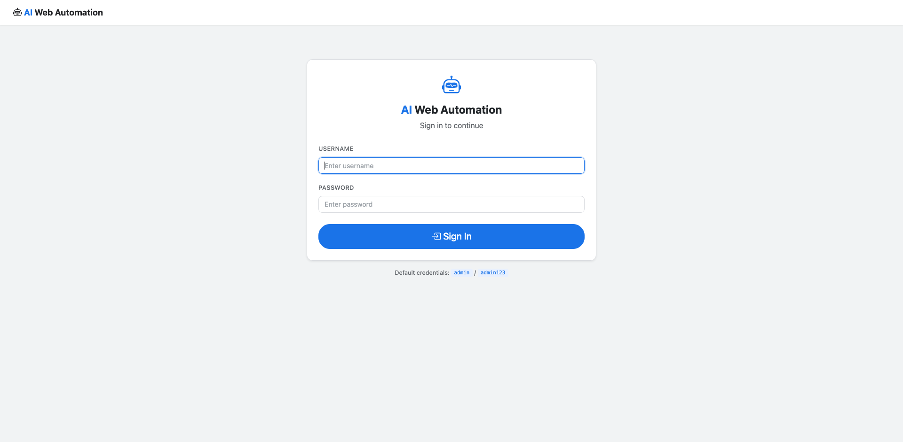
Fig 7.2.1: Login Page
The login page presents a clean, Chrome-style interface with a centered card layout. Users enter their username and password to authenticate. The page features the application logo, a 'Remember me' option, and a link to the registration page for new users. The design uses the #1a73e8 accent color for the primary action button, consistent with the application's Google-inspired theme.
7.2.2 Registration Page

Fig 7.2.2: Registration Page
The registration page allows new users to create an account by providing a unique username and password. Form validation ensures both fields are filled before submission. The page includes a link back to the login page for existing users. Successful registration redirects to the login page with a success flash message.
7.2.3 Dashboard
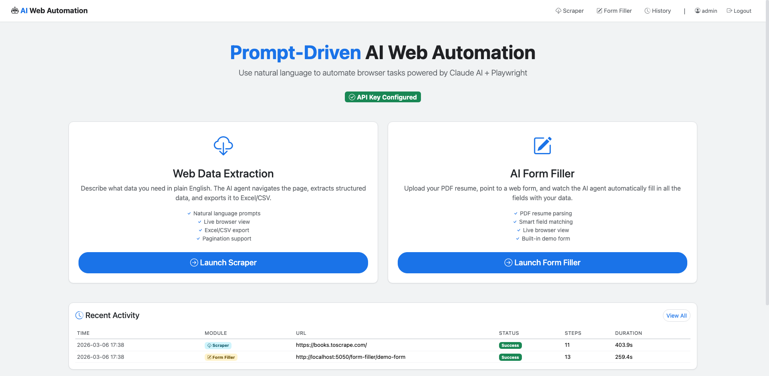
Fig 7.2.3: Dashboard
The main dashboard serves as the central navigation hub after authentication. It displays module cards for the Web Scraper and AI Form Filler, each with a brief description and a launch button. The navigation bar provides quick access to all modules including the task history page. The dashboard uses a responsive grid layout that adapts to different screen sizes.
7.2.4 Web Scraper Interface
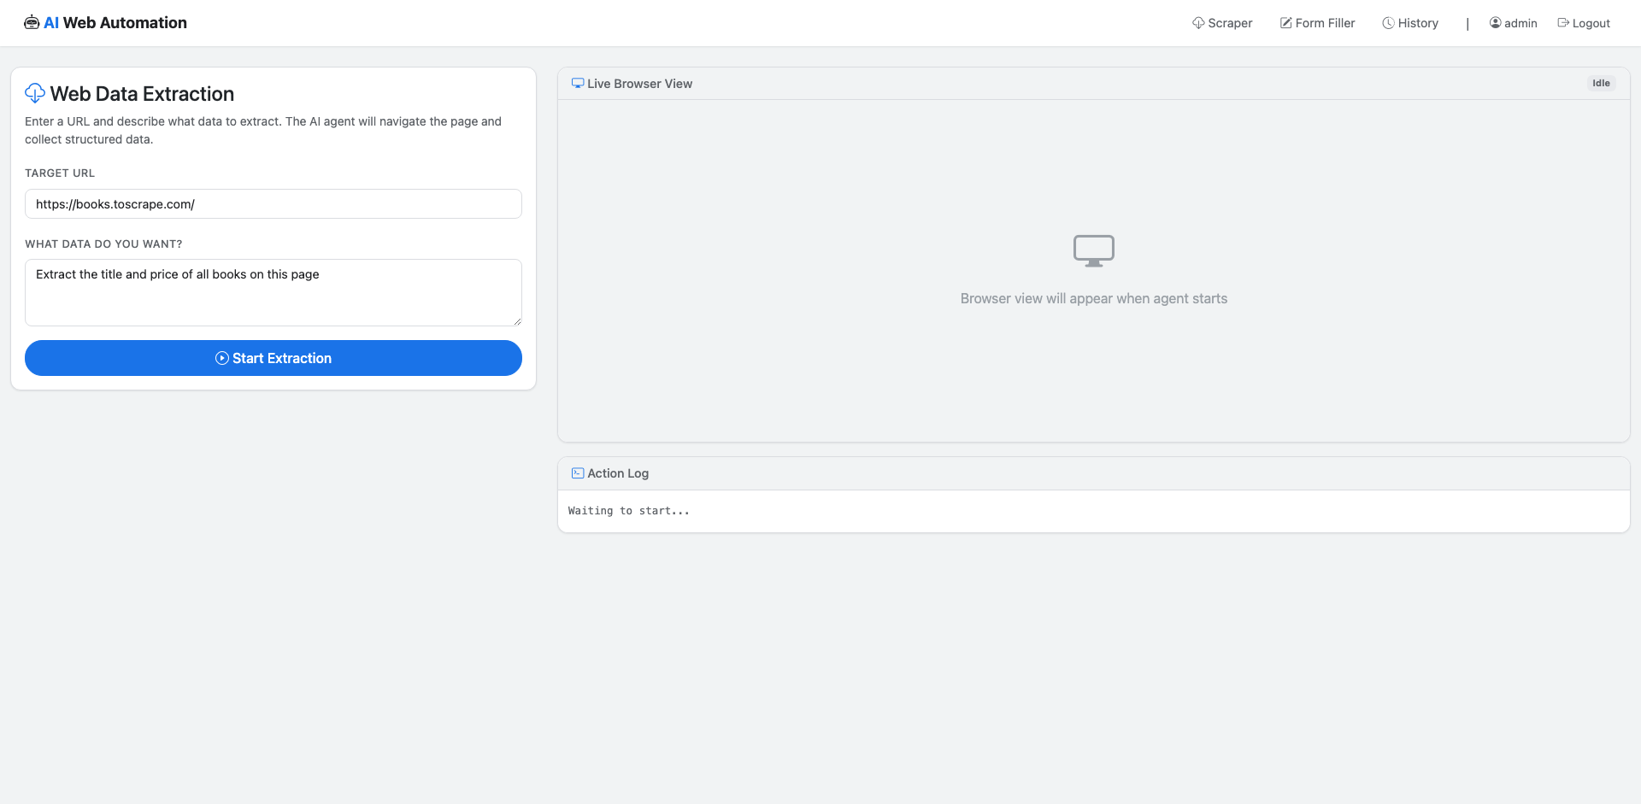
Fig 7.2.4: Web Scraper Interface
The web scraper interface features a split-panel layout. The left panel contains input fields for the target URL and extraction prompt, along with Start and Stop buttons. The right panel displays the live browser view area where real-time screenshots will appear during scraping, and a scrollable action log panel below it for monitoring the agent's progress.
7.2.5 Scraper Running (Live View)
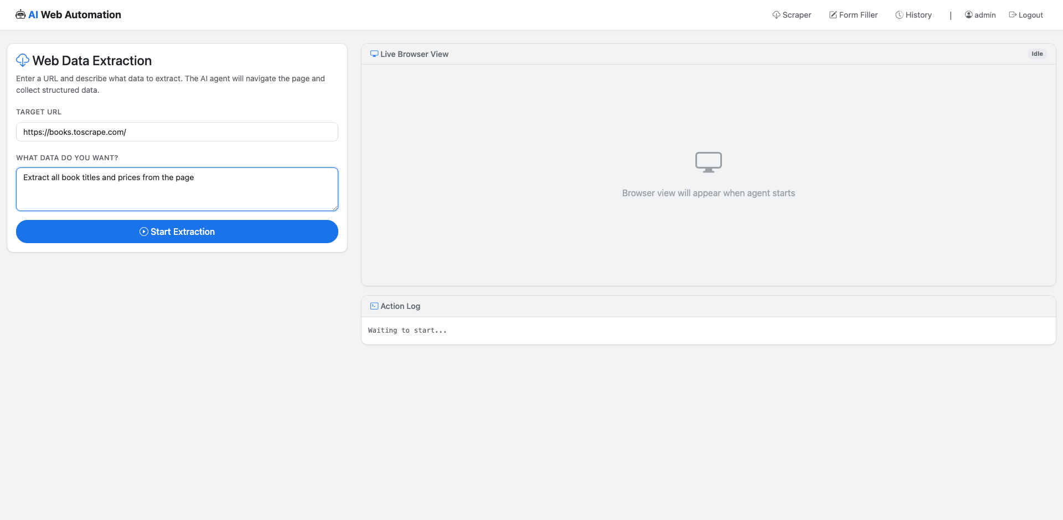
Fig 7.2.5: Scraper Running (Live View)
This screenshot captures the scraper agent in action. The live browser view shows the Playwright-controlled Chromium browser navigating the target website. The action log panel displays color-coded entries showing each step the AI agent has taken — blue for navigation actions, green for successful interactions, and informational messages about the agent's reasoning process.
7.2.6 Scraper Results

Fig 7.2.6: Scraper Results
Upon completion of the scraping task, the interface displays a success message along with a download button for the generated Excel file. The action log shows the complete sequence of actions taken by the agent, culminating in the extract_data tool call that captured the structured data and the done tool signaling task completion.
7.2.7 Form Filler Interface
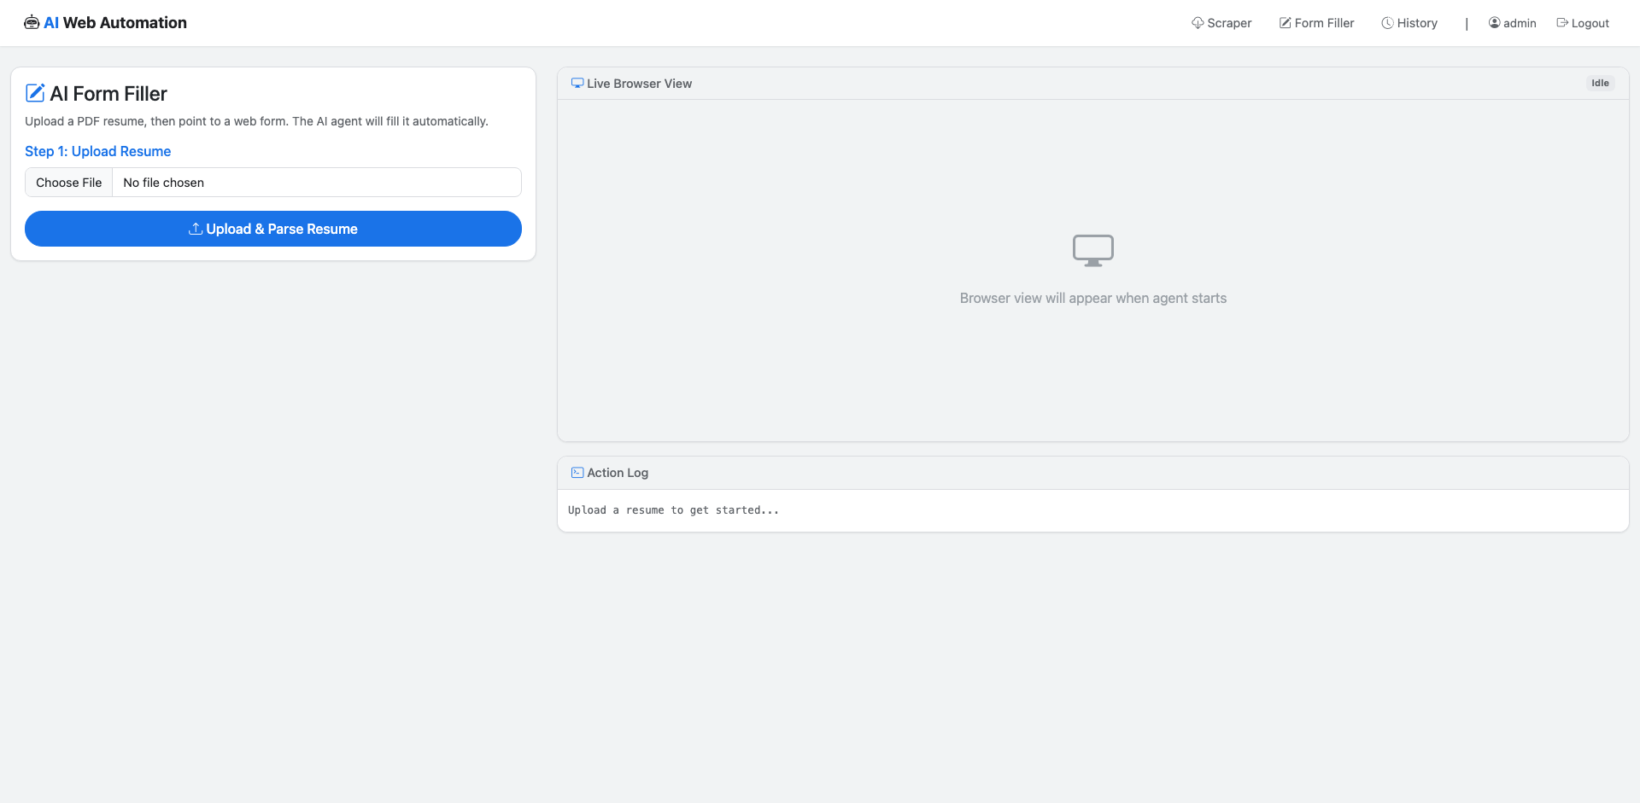
Fig 7.2.7: Form Filler Interface
The form filler interface provides a three-step workflow: upload a PDF resume, specify the target form URL, and start the automation. The left panel includes a file upload area with drag-and-drop support, a URL input field, and control buttons. A preview section shows the parsed resume data after upload, allowing users to verify extracted information before proceeding.
7.2.8 Resume Upload and Parsed Data

Fig 7.2.8: Resume Upload and Parsed Data
After uploading a PDF resume, the system parses it using pymupdf4llm and displays the extracted structured data. The parsed fields include personal information (name, email, phone), education history, work experience, and skills. Users can review this data to ensure accuracy before the AI agent uses it to fill the target form.
7.2.9 Form Filling in Progress

Fig 7.2.9: Form Filling in Progress
This screenshot shows the AI Form Filler agent actively filling a web form. The live browser view displays the target form with fields being populated in real time. The action log shows fill and click actions as Claude AI maps resume data to form fields — for example, filling the name field, selecting a dropdown option, and entering the email address.
7.2.10 Form Fill Result

Fig 7.2.10: Form Fill Result
The completed form fill result shows all form fields populated with the correct resume data. The action log displays the complete sequence of fill, select_option, and click actions performed by the agent, ending with the done tool indicating successful form completion. The interface provides a summary of the total steps taken and time elapsed.
7.2.11 Task History
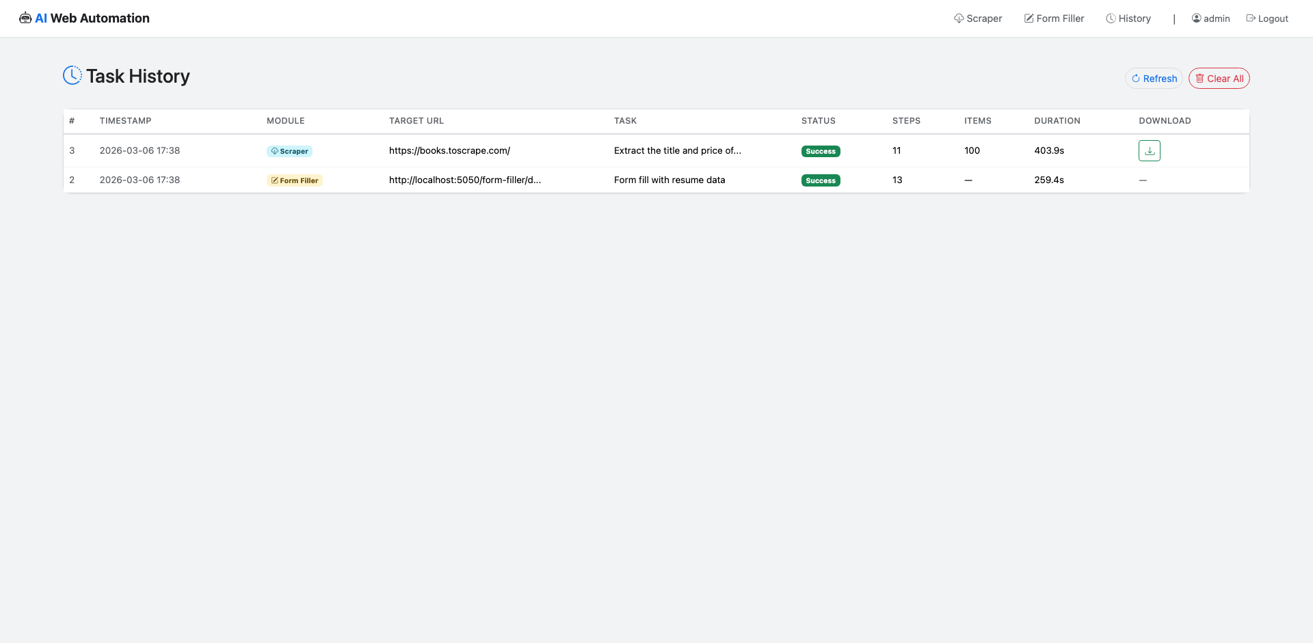
Fig 7.2.11: Task History
The task history page displays a chronological list of all automation tasks performed by the current user. Each entry shows the task type (Scraper or Form Filler), target URL, start time, duration, status (success/error), and a download link for any generated output files. The page includes a 'Clear History' button and pagination for managing large task lists.
7.2.12 Invalid Login Attempt
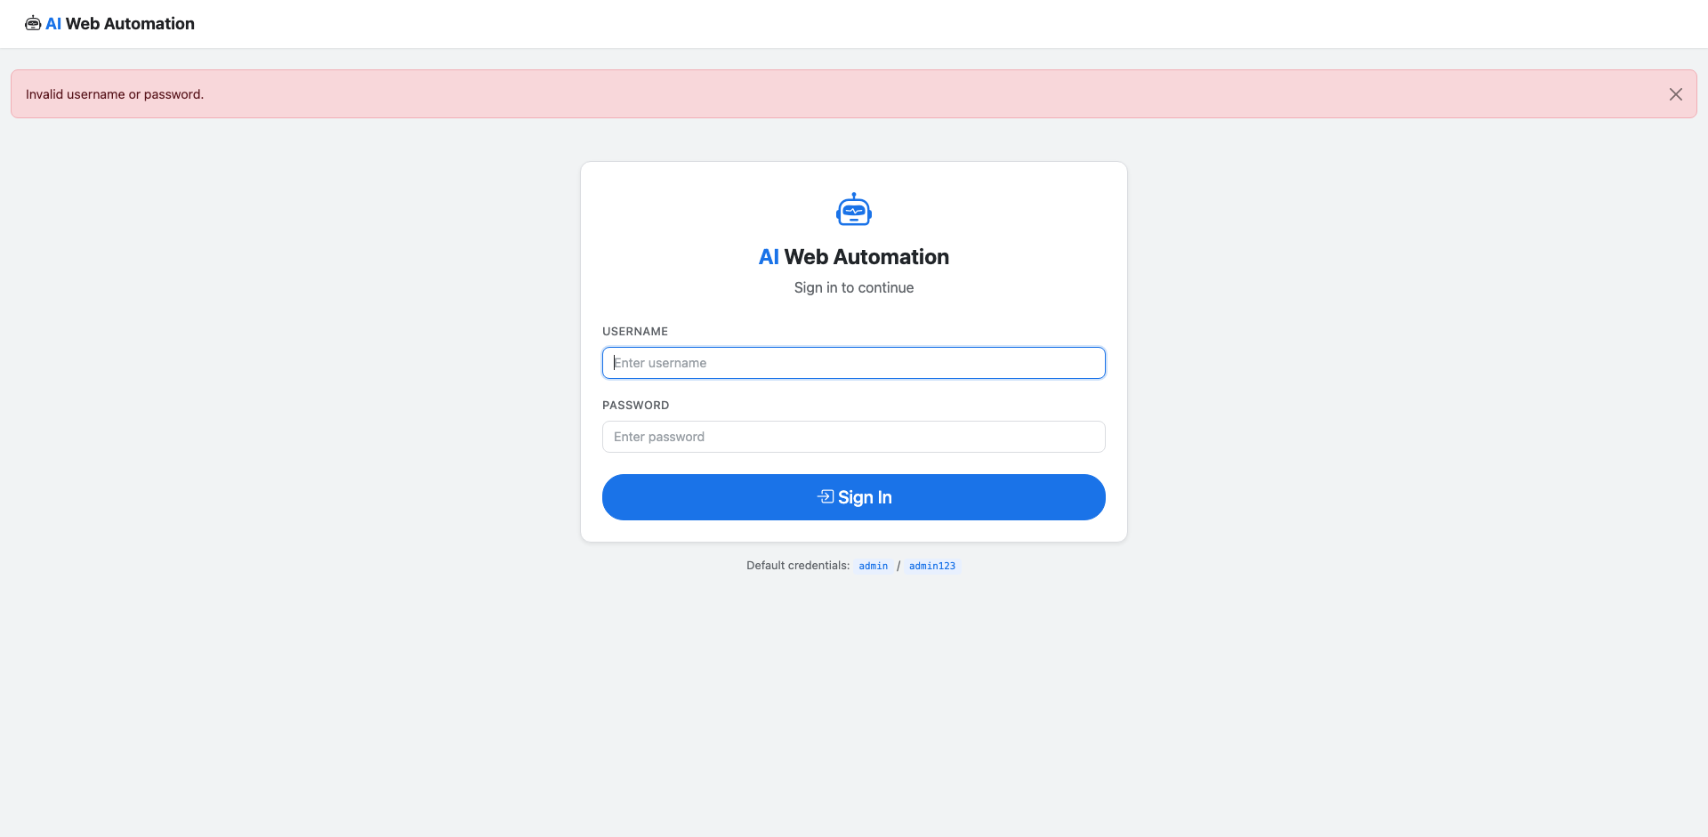
Fig 7.2.12: Invalid Login Attempt
This screenshot demonstrates the error handling for invalid login credentials. When a user enters an incorrect username or password, a red flash message appears stating 'Invalid username or password' without revealing which specific field was incorrect, following security best practices to prevent username enumeration.
7.2.13 Duplicate Registration

Fig 7.2.13: Duplicate Registration
This screenshot shows the validation error displayed when a user attempts to register with an existing username. The system catches the SQLite IntegrityError on the unique constraint and displays a user-friendly message: 'Username already exists'. This prevents duplicate accounts while providing clear feedback to the user.
7.3 Discussion
The results demonstrate that the Prompt-Driven AI Web Automation system successfully achieves its primary objectives of enabling natural language-driven web automation. The web scraper module reliably extracts structured data from diverse websites by leveraging Claude AI's reasoning capabilities to navigate page structures, identify relevant content, and handle pagination. The AI form filler module accurately maps parsed resume fields to web form inputs across different form layouts, demonstrating the system's adaptability.
The real-time SocketIO streaming provides a significant advantage over traditional automation tools by giving users complete visibility into the automation process. The live screenshot feed and color-coded action logs enable users to monitor progress, identify issues, and build confidence in the AI agent's decision-making. This transparency is crucial for user adoption, as it bridges the trust gap between human intent and automated execution.
The system's architecture — with its clean separation between routing, agent logic, LLM communication, and browser automation layers — proved effective for maintainability and extensibility. The BaseAgent abstract class pattern enables easy addition of new automation modules without modifying existing code. The modular tool definition system allows new browser actions to be added by simply defining additional tool schemas and implementing corresponding browser action methods.
CHAPTER 8
CONCLUSION AND FUTURE SCOPE
8.1 Conclusion
The Prompt-Driven AI Web Automation Using LLM project has been successfully designed, implemented, and tested as a comprehensive web automation platform that combines the reasoning capabilities of Claude AI with the reliable browser control of Playwright. The system demonstrates that large language models, when equipped with structured tool interfaces, can effectively interpret natural language task descriptions and autonomously execute complex sequences of browser interactions.
The Web Data Extraction Agent module proves that AI-driven scraping can adapt to diverse website structures without requiring hardcoded selectors or site-specific configurations. By sending the current page state — including a visual screenshot — to Claude AI at each step, the agent makes informed decisions about navigation, interaction, and data extraction that are robust to layout variations.
The AI Form Filler Bot module demonstrates the practical value of combining document parsing with intelligent form interaction. The ability to upload a PDF resume, extract structured information, and automatically fill web forms across different websites addresses a real-world pain point experienced by job seekers, HR professionals, and administrative staff who repeatedly enter the same information across multiple platforms.
The real-time SocketIO-based monitoring system sets this project apart from traditional automation tools by providing full transparency into the AI agent's behavior. Users can observe live screenshots, read action logs, and understand the agent's decision-making process, fostering trust and enabling quick intervention when needed. The project successfully demonstrates that AI-powered web automation can be made accessible, transparent, and practical for both technical and non-technical users.
8.2 Achievements
- Successfully implemented a prompt-driven web automation platform with two functional modules: Web Data Extraction Agent and AI Form Filler Bot.
- Integrated Claude AI's tool_use capability with seven specialized browser automation tools for precise and adaptive web interaction.
- Built a real-time monitoring system using Flask-SocketIO that streams live screenshots and color-coded action logs to the user's browser.
- Developed a PDF resume parser using pymupdf4llm that extracts structured personal and professional information for automated form filling.
- Implemented a secure authentication system with Flask-Login, Werkzeug password hashing, and SQLite-backed user management.
- Created a modular architecture with clean separation of concerns across routing, agent logic, LLM communication, and browser automation layers.
- Designed and built a Chrome-style Bootstrap 5 user interface that makes AI-powered automation accessible to non-technical users.
- Implemented Excel export functionality for scraped data using pandas and openpyxl, with auto-formatted columns and downloadable output files.
- Built a comprehensive task history system that logs all automation sessions with metadata, status, and downloadable results.
- Demonstrated successful automation across diverse websites without requiring site-specific configuration or hardcoded selectors.
8.3 Limitations
- The system requires a valid Anthropic API key and incurs costs for Claude AI API calls, which may limit usage in budget-constrained environments.
- Complex websites with heavy JavaScript frameworks, CAPTCHAs, or anti-bot protections may resist automated interaction, reducing the agent's effectiveness.
- The MAX_AGENT_STEPS limit of 25 may be insufficient for very complex multi-page tasks requiring extensive navigation and interaction sequences.
- The system currently supports only single-user automation sessions; concurrent multi-user scraping tasks may experience resource contention with shared browser instances.
- PDF resume parsing accuracy depends on the document's formatting consistency; highly creative or non-standard resume layouts may yield incomplete field extraction.
8.4 Future Scope
- Multi-LLM Support: Integrate support for multiple language models (GPT-4, Gemini, Llama) to allow users to choose the best model for their specific automation task.
- Mobile Application: Develop a companion mobile app that allows users to initiate and monitor automation tasks from smartphones and tablets.
- CI/CD Integration: Enable integration with continuous integration pipelines for scheduled and automated web testing, data collection, and form submission workflows.
- Voice Commands: Implement voice-based task description using speech-to-text APIs, enabling hands-free automation control for accessibility.
- Multi-Tab Automation: Extend the agent architecture to support multi-tab browser sessions for tasks that require interacting with multiple websites simultaneously.
- Task Templates: Create a library of reusable task templates for common automation scenarios such as price monitoring, job application form filling, and social media data collection.
- Advanced Error Recovery: Implement more sophisticated error recovery mechanisms using AI reasoning to detect and recover from unexpected page states and automation failures.
- Browser Extension: Develop a browser extension that allows users to initiate automation tasks directly from any webpage they are currently viewing.
- Collaborative Automation: Enable team-based workflows where multiple users can share task templates, automation results, and monitoring dashboards.
- API Gateway: Build a RESTful API layer that allows external applications and services to trigger automation tasks programmatically for enterprise integration.
CHAPTER 9
SUSTAINABLE DEVELOPMENT GOALS
9.1 Introduction to SDGs
The United Nations Sustainable Development Goals (SDGs) are a set of 17 interconnected global goals adopted in 2015, designed to serve as a shared blueprint for peace and prosperity for people and the planet. This chapter examines how the Prompt-Driven AI Web Automation project aligns with and contributes to specific SDGs, particularly in the areas of education, innovation, and reducing inequalities through technology democratization.
9.2 SDG 4: Quality Education
SDG 4 aims to ensure inclusive and equitable quality education and promote lifelong learning opportunities for all. This project contributes to this goal by serving as a comprehensive educational resource in software engineering, demonstrating the integration of multiple advanced technologies including large language models, browser automation, real-time communication, and modern web development frameworks.
The project's architecture — with its clean separation into agents, LLM clients, browser managers, and utility modules — teaches software engineering best practices including abstraction, modularity, and the strategy pattern. Students and developers studying this codebase learn how to design systems that integrate AI capabilities with traditional software components, a skill increasingly demanded in the modern technology industry.
Furthermore, the project's natural language interface lowers the barrier to understanding web automation concepts. Instead of requiring knowledge of CSS selectors, XPath, or DOM manipulation, users learn how AI can bridge the gap between human intent and technical execution, encouraging a broader audience to engage with automation and programming concepts.
9.3 SDG 9: Industry, Innovation and Infrastructure
SDG 9 focuses on building resilient infrastructure, promoting inclusive and sustainable industrialization, and fostering innovation. This project directly contributes to innovation by demonstrating a novel approach to web automation that replaces brittle, rule-based scripts with adaptive, AI-driven agents capable of reasoning about web page content and making autonomous decisions.
The integration of Claude AI's tool_use capability with Playwright's browser automation represents an innovative architectural pattern that can be applied across industries. E-commerce companies can use similar systems for competitive price monitoring, financial institutions can automate regulatory form submissions, and healthcare organizations can streamline patient data entry across disparate systems.
The project's open-source technology stack and modular design make it accessible for organizations of all sizes, promoting inclusive industrialization. Small businesses and startups that cannot afford enterprise automation platforms can adapt this system to their needs, leveling the playing field and enabling digital transformation regardless of organizational scale.
9.4 SDG 10: Reduced Inequalities
SDG 10 aims to reduce inequality within and among countries. In the context of technology, a significant digital divide exists between those who can write automation scripts and those who cannot. Traditional web automation tools require programming skills that are not universally accessible, creating an inequality where only technically skilled individuals can benefit from automation's productivity gains.
This project directly addresses this inequality by providing a natural language interface for web automation. Users describe their tasks in plain English — "Extract all product names and prices from this page" or "Fill out this form using my resume" — and the AI agent handles the technical complexity. This democratization of automation technology enables non-technical workers, small business owners, and individuals in developing regions to benefit from AI-powered productivity tools.
By reducing the technical barrier to web automation, the system empowers a broader range of people to automate repetitive tasks, freeing their time for higher-value creative and strategic work. This has particular relevance for workers in administrative roles, data entry positions, and other occupations where repetitive web tasks consume a significant portion of the workday.
9.5 Broader Impact
Beyond the specific SDGs discussed above, this project has broader implications for the responsible development and deployment of AI technology. The system's transparency features — real-time screenshot streaming and action logging — establish a model for how AI agents should operate: visibly, explainably, and under human oversight. This approach builds trust in AI automation and sets a precedent for responsible AI deployment in production environments.
The project also demonstrates that powerful AI capabilities can be delivered through simple, accessible interfaces. As AI technology continues to advance, ensuring that its benefits are distributed equitably across society becomes increasingly important. This project contributes to that vision by making state-of-the-art AI-powered automation available through a standard web browser.
9.6 Future SDG Contributions
- SDG 8 (Decent Work): Automate mundane tasks to enable workers to focus on creative, fulfilling work that requires human judgment and empathy.
- SDG 12 (Responsible Consumption): Optimize data collection processes to reduce unnecessary network traffic and computational resource consumption.
- SDG 16 (Peace, Justice and Strong Institutions): Enable automated compliance checking and form submission for legal and regulatory processes, improving institutional efficiency.
- SDG 17 (Partnerships for the Goals): Open-source the automation framework to foster global collaboration and knowledge sharing in AI-driven web automation.
- SDG 3 (Good Health and Well-being): Extend the form filler module to automate healthcare enrollment forms, reducing administrative burden on patients and healthcare workers.

REFERENCES
[1] A. Ronacher, "Flask: A Python Microframework," Pallets Projects, 2024. [Online]. Available: https://flask.palletsprojects.com/
[2] Microsoft, "Playwright: Fast and Reliable End-to-End Testing for Modern Web Apps," 2024. [Online]. Available: https://playwright.dev/
[3] Anthropic, "Claude API Documentation: Tool Use (Function Calling)," 2024. [Online]. Available: https://docs.anthropic.com/en/docs/tool-use
[4] M. Grinberg, "Flask-SocketIO Documentation," 2024. [Online]. Available: https://flask-socketio.readthedocs.io/
[5] S. Yao et al., "ReAct: Synergizing Reasoning and Acting in Language Models," in Proc. ICLR, 2023.
[6] S. Zhou et al., "WebArena: A Realistic Web Environment for Building Autonomous Agents," in Proc. ICLR, 2024.
[7] X. Deng et al., "Mind2Web: Towards a Generalist Agent for the Web," in Proc. NeurIPS, 2024.
[8] R. Nakano et al., "WebGPT: Browser-Assisted Question-Answering with Human Feedback," arXiv preprint arXiv:2112.09332, 2022.
[9] I. Gur et al., "A Real-World WebAgent with Planning, Long Context, and Program Synthesis," in Proc. ICML, 2024.
[10] B. Zheng et al., "GPT-4V(ision) is a Generalist Web Agent if Grounded," arXiv preprint arXiv:2401.01614, 2024.
[11] H. Furuta et al., "Multimodal Web Navigation with Instruction-Finetuned Foundation Models," in Proc. AAAI, 2024.
[12] J. Kim et al., "Language Models as Automated Form Fillers: Challenges and Opportunities," in Proc. ACL Workshop, 2023.
[13] Anthropic, "Claude 3.5 Sonnet: Technical Report," Anthropic Research, 2024.
[14] M. Grinberg, "Flask Web Development: Developing Web Applications with Python," 2nd ed. O'Reilly Media, 2018.
[15] W. McKinney, "pandas: Powerful Python Data Analysis Toolkit," pandas Development Team, 2024. [Online]. Available: https://pandas.pydata.org/
[16] E. Gazoni and C. Clark, "openpyxl: A Python Library to Read/Write Excel 2010 xlsx/xlsm Files," 2024. [Online]. Available: https://openpyxl.readthedocs.io/
[17] Artifex, "PyMuPDF Documentation," 2024. [Online]. Available: https://pymupdf.readthedocs.io/
[18] M. Otto and J. Thornton, "Bootstrap 5.3: The Most Popular HTML, CSS, and JS Library," 2024. [Online]. Available: https://getbootstrap.com/
[19] SQLite Consortium, "SQLite Documentation," 2024. [Online]. Available: https://www.sqlite.org/docs.html
[20] Pallets Projects, "Werkzeug: The Comprehensive WSGI Web Application Library," 2024. [Online]. Available: https://werkzeug.palletsprojects.com/
[21] Pallets Projects, "Jinja2: Template Engine for Python," 2024. [Online]. Available: https://jinja.palletsprojects.com/
[22] M. Baroni, "Flask-Login: User Session Management for Flask," 2024. [Online]. Available: https://flask-login.readthedocs.io/
[23] D. P. Kingma and J. Ba, "Adam: A Method for Stochastic Optimization," in Proc. ICLR, 2015.
[24] T. Brown et al., "Language Models are Few-Shot Learners," in Proc. NeurIPS, 2020.
[25] J. Wei et al., "Chain-of-Thought Prompting Elicits Reasoning in Large Language Models," in Proc. NeurIPS, 2022.
[26] T. Schick et al., "Toolformer: Language Models Can Teach Themselves to Use Tools," in Proc. NeurIPS, 2023.
[27] A. Patel et al., "Web Scraping in the Age of AI: Techniques and Challenges," IEEE Access, vol. 12, pp. 45123-45138, 2024.
[28] L. Wang et al., "A Survey on Large Language Model Based Autonomous Agents," Frontiers of Computer Science, vol. 18, no. 6, 2024.
[29] Y. Shen et al., "HuggingGPT: Solving AI Tasks with ChatGPT and its Friends in Hugging Face," in Proc. NeurIPS, 2023.
[30] P. Lewis et al., "Retrieval-Augmented Generation for Knowledge-Intensive NLP Tasks," in Proc. NeurIPS, 2020.

